Lappeenrannan teknillinen yliopisto

School of Business and Management

Sofware Development Skills

<AchmadYusuf>, <Insert student number here>

LEARNING DIARY, <Mobile 2022-23> MODULE

**LEARNING DIARY**

**EXAMPLE STYLE 1**

10.2.2023  
  
I checked the general information and understood the main focus of the course, which is to find my passion as a software developer and create a unique project to represent my skills. I chose Mobile module because it was the most interesting project offered. I’ve also tried to set up my environment, Android Studio. I learned to set up a git repository and did my first commit.

one of problem is related to file dependency as shown below text, I just remove 33, then I can built a project.

Unable to resolve dependency for ':app@debug/compileClasspath': Could not find any version that matches com.android.support:appcompat-v7:33.+.

Open File

Show Details

another problem is when using web service api I need to impor ksoap2. detail step can be seen on detail Part below.

I know how to debug in android studio, for detail information see below part

14,2,2023

this Day I was trying to use web service but I have problem when parshing the response of webservice. There is problem with xml therefore I have to use XMLparsher.

17,2,2023

creating menu in Android base on user level.

goto app,res,drawable and right click new vector asset

18,2,2023

create spinner/ dropdownlist with key and value

create new class

19,2,2023 Creating datepicker

create Calendar to input date in mobile

28,2,2023 gridview

I create Gridview

Detail Part

1.Environtment installation

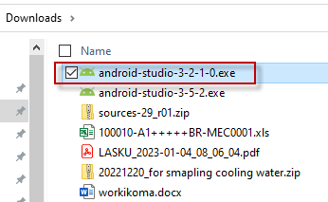

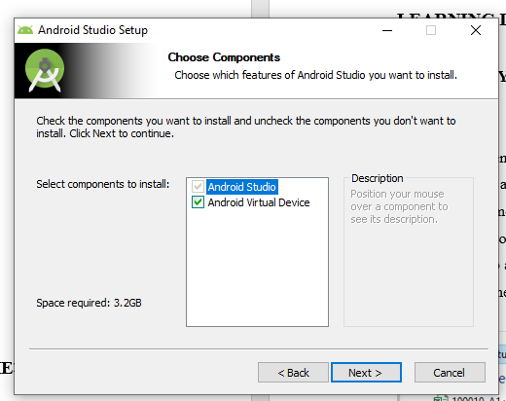

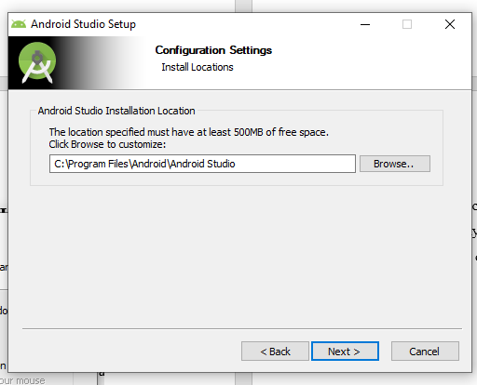

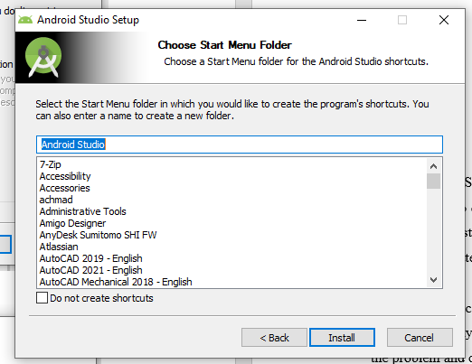

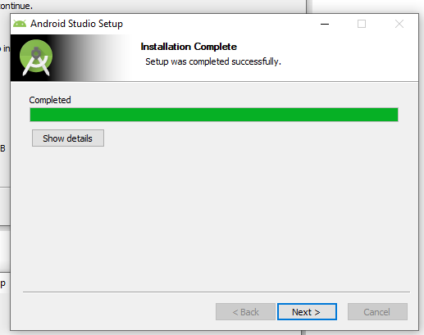

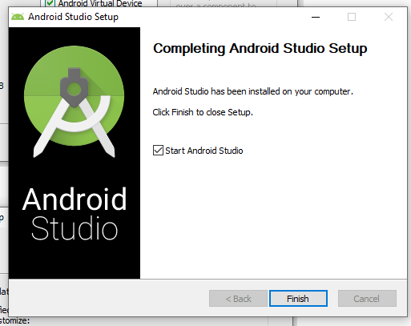

after finish we create new project

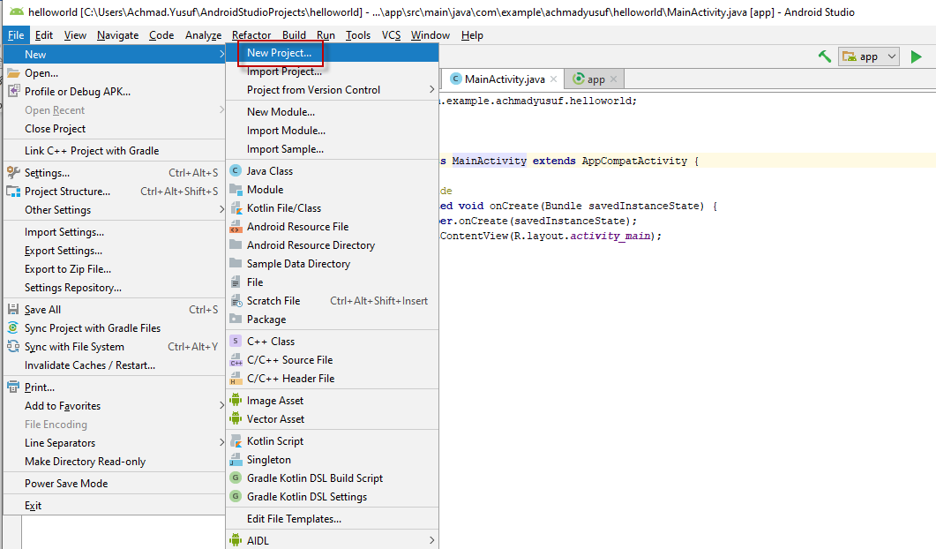

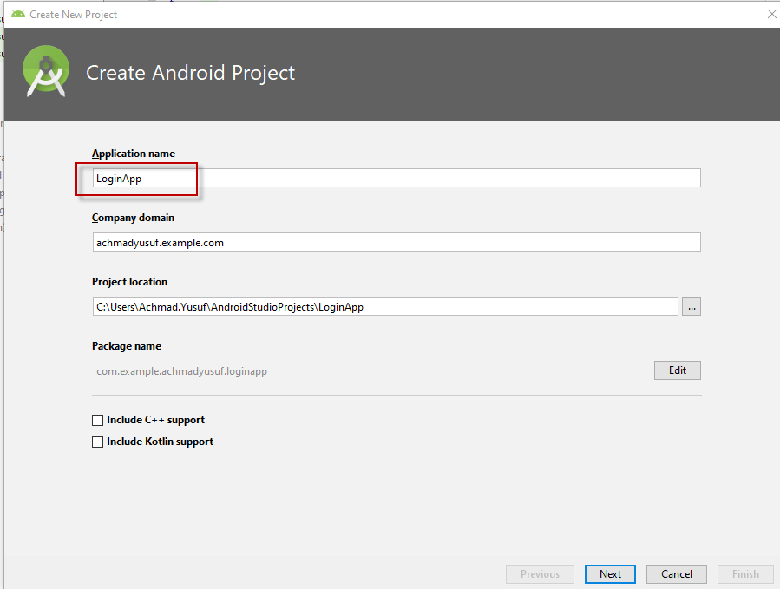

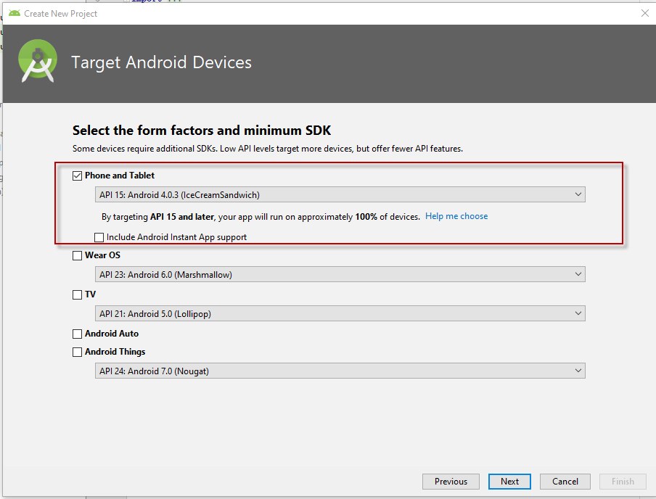

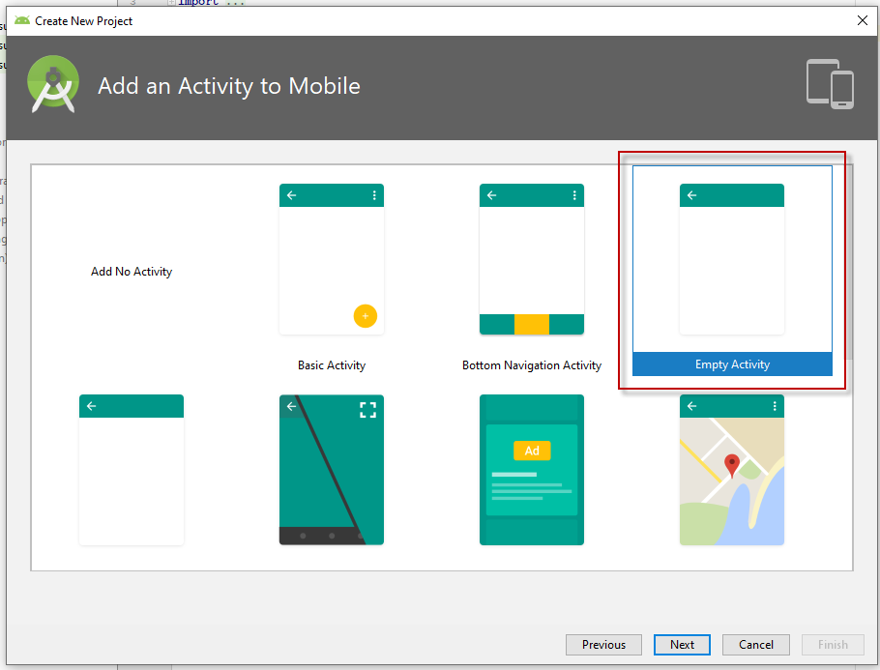

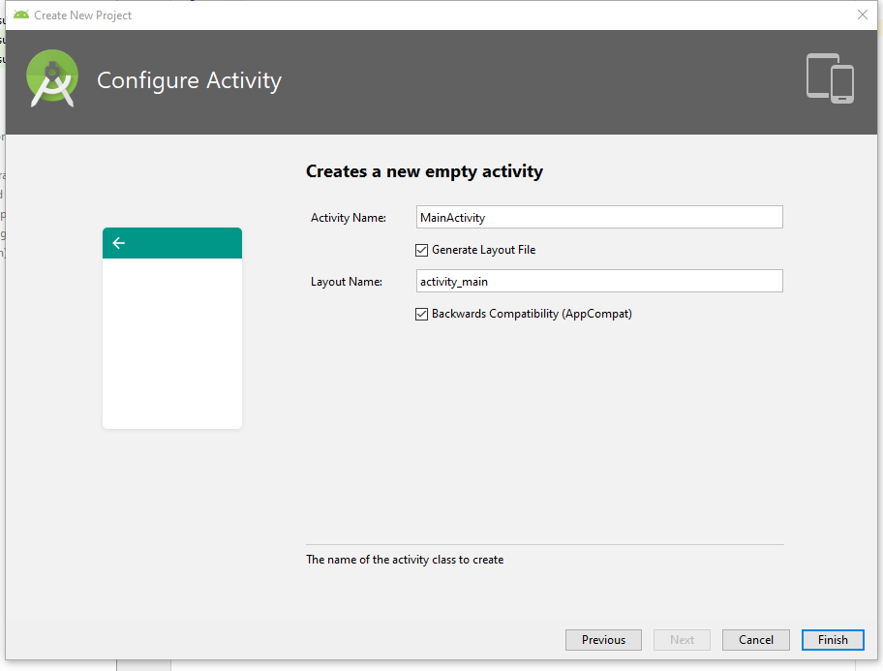

Unable to resolve dependency for ':app@debug/compileClasspath': Could not find any version that matches com.android.support:appcompat-v7:33.+.

Open File

Show Details

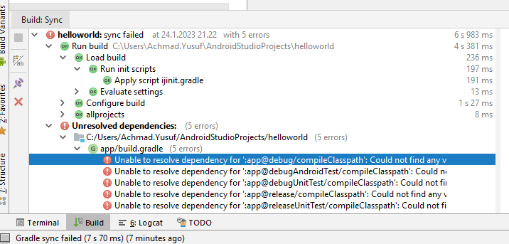

change appcompt-v7:30+ tp -v7;+ inside build-gradle(module:app)

dependencies {  
 implementation fileTree(**dir**: **'libs'**, **include**: [**'*.jar'**])  
 implementation **'com.android.support:appcompat-v7:+'** implementation **'com.android.support.constraint:constraint-layout:2.0.4'** testImplementation **'junit:junit:4.12'** androidTestImplementation **'com.android.support.test:runner:1.0.2'** androidTestImplementation **'com.android.support.test.espresso:espresso-core:3.0.2'**}

then error in build.gradle gone

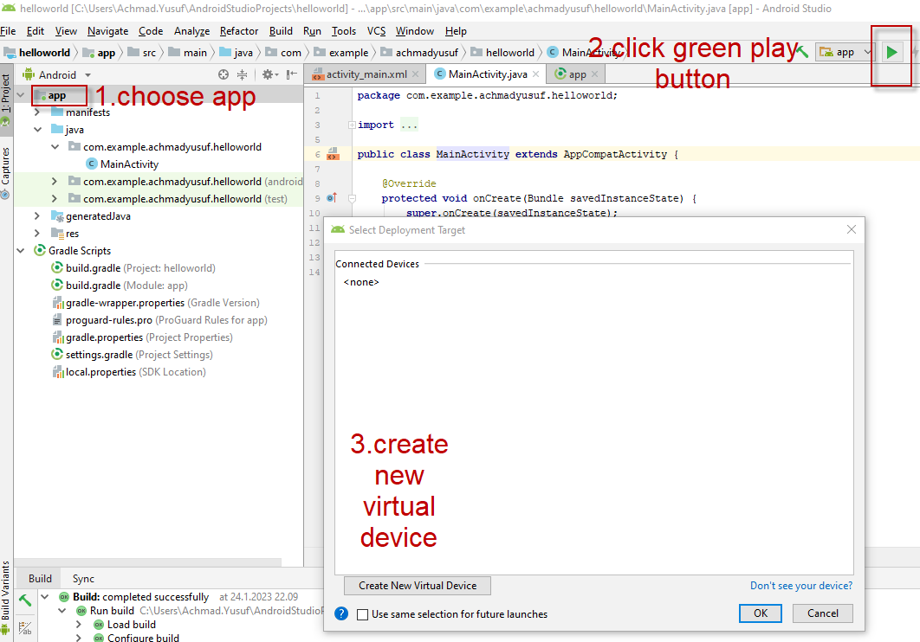

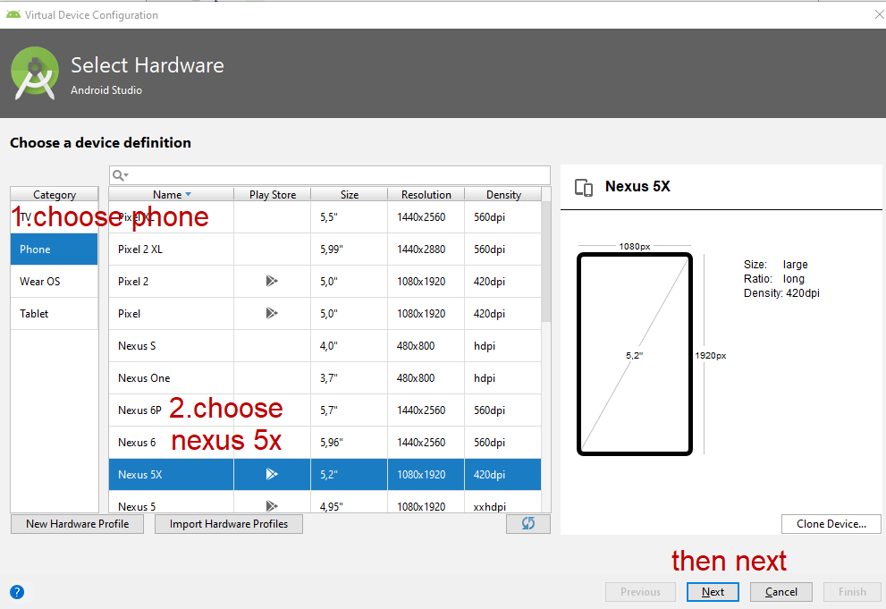

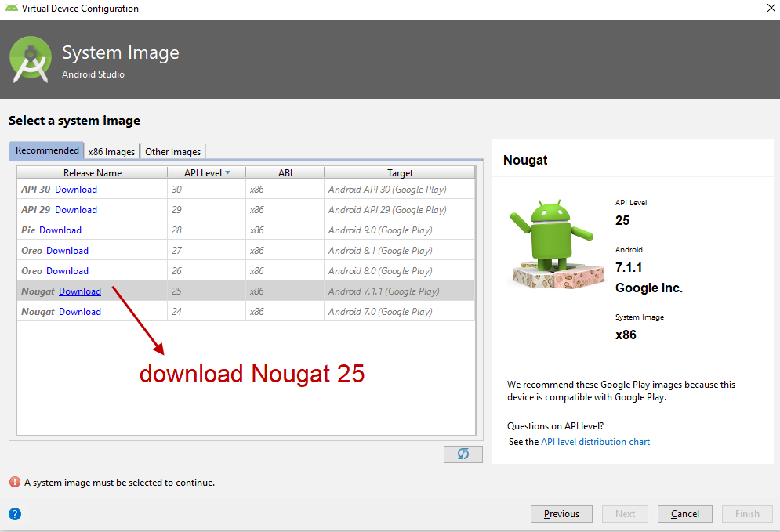

THEN download finish as shown in picture below

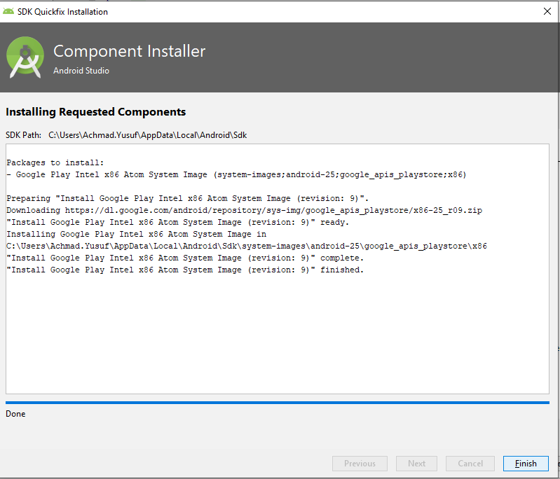

then next

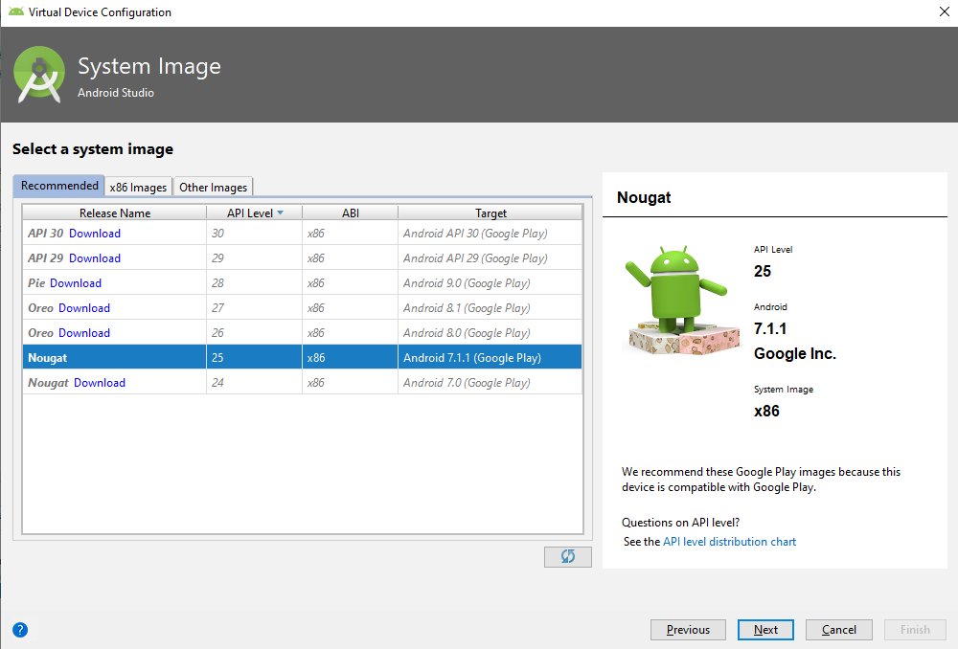

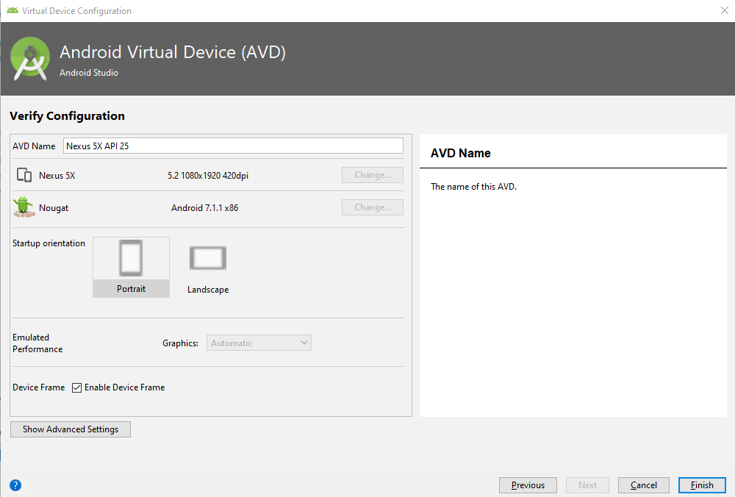

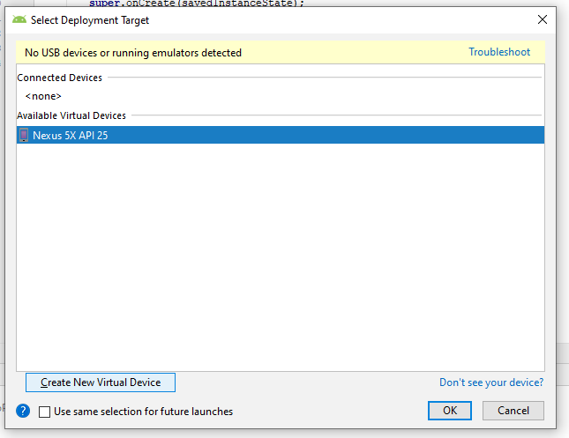

just ok

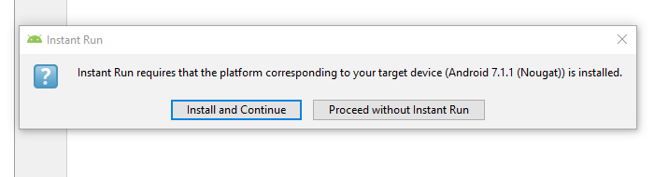

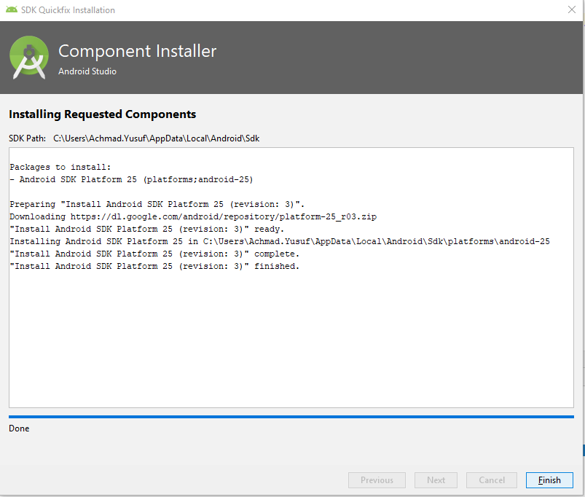

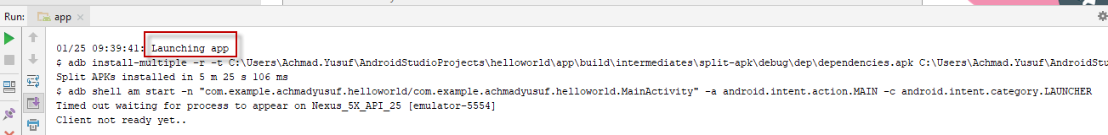

launching emulator succeed

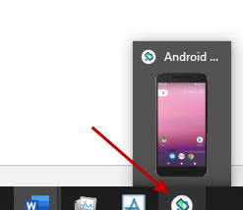

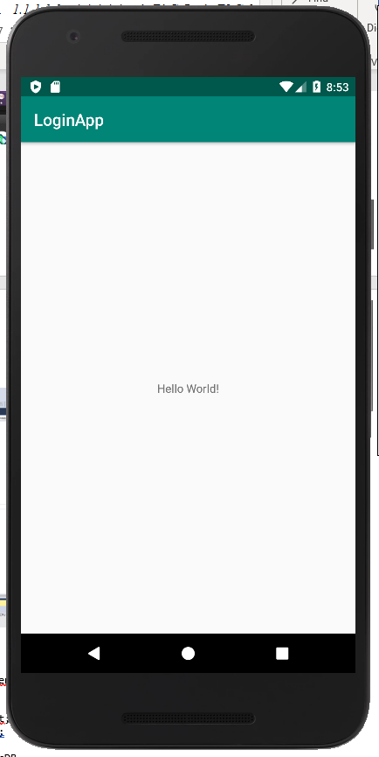

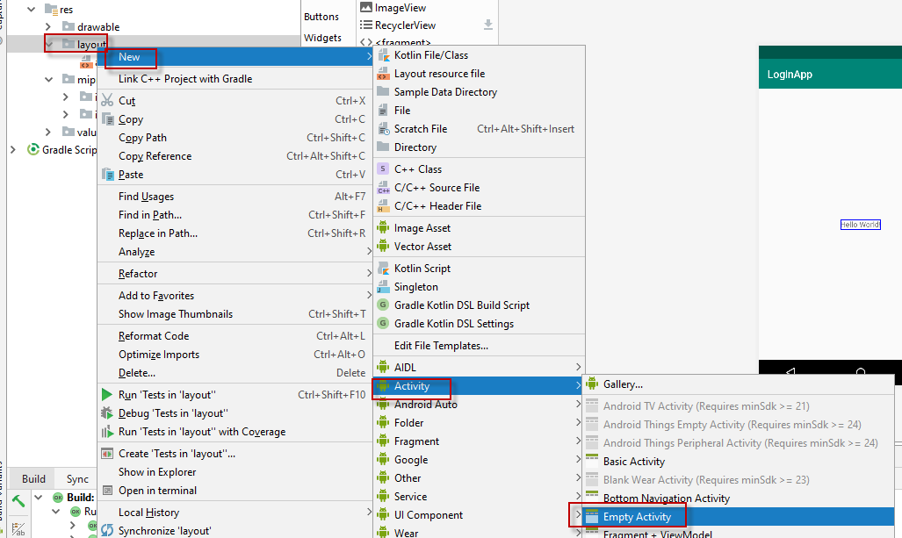

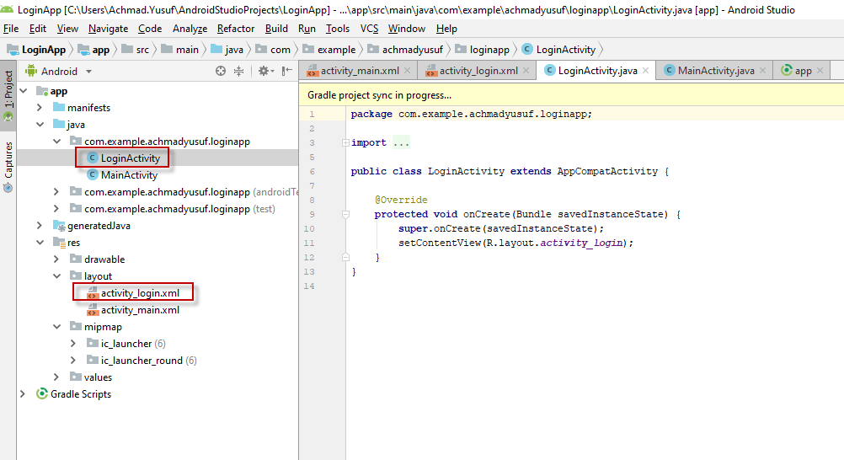

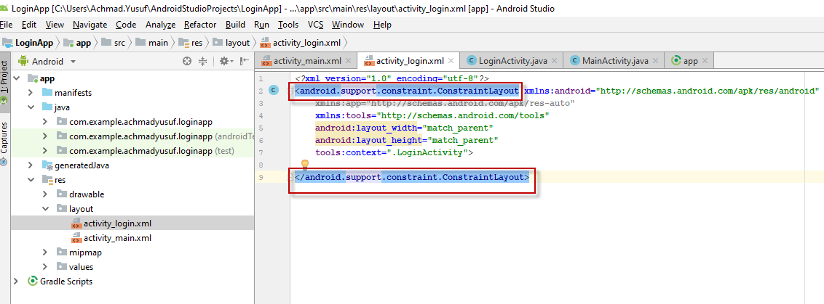

change to relatifelayout

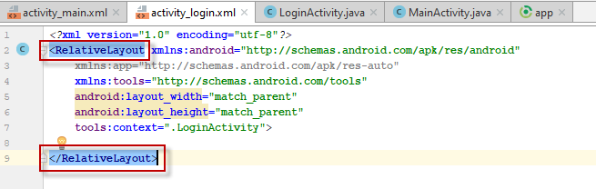

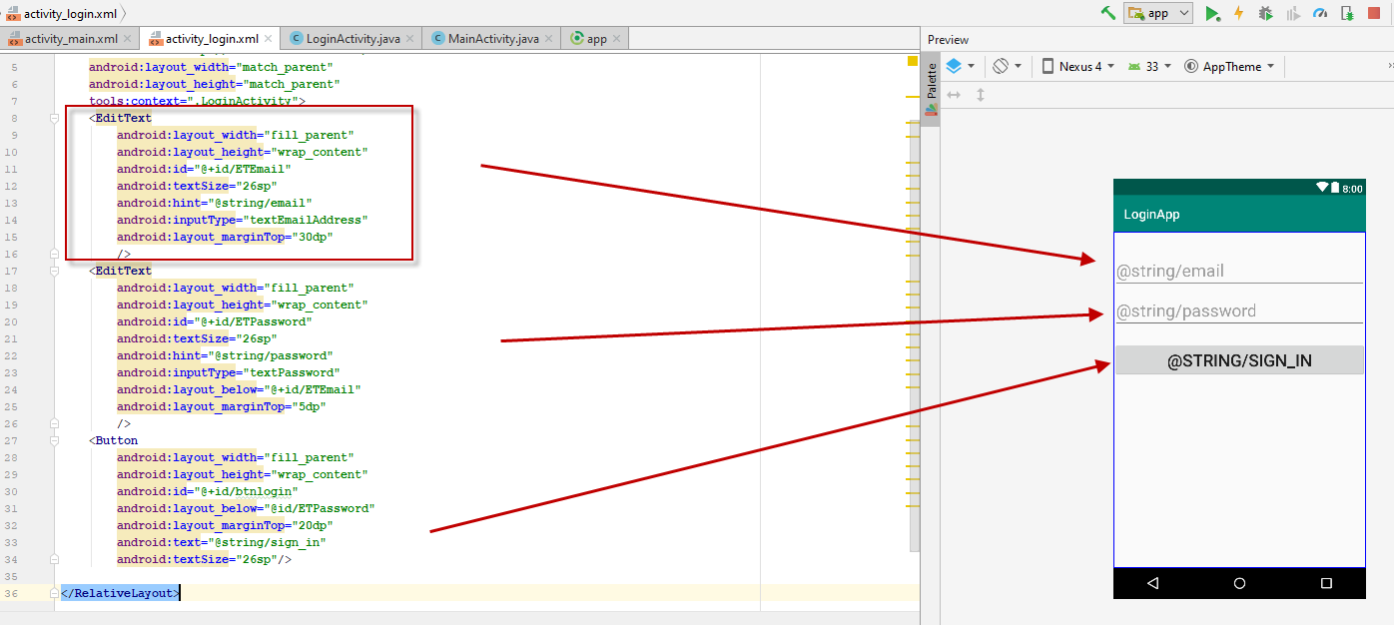

change string value

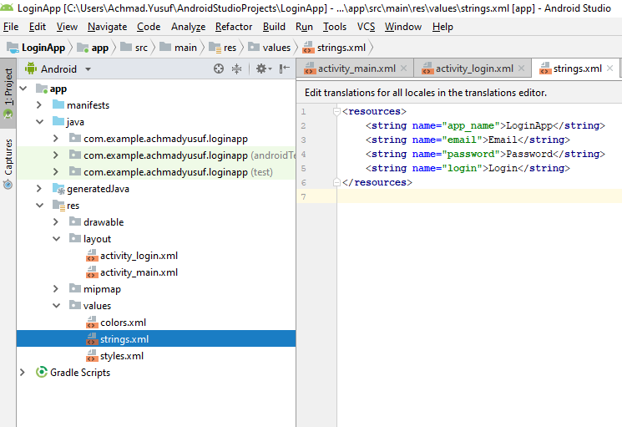

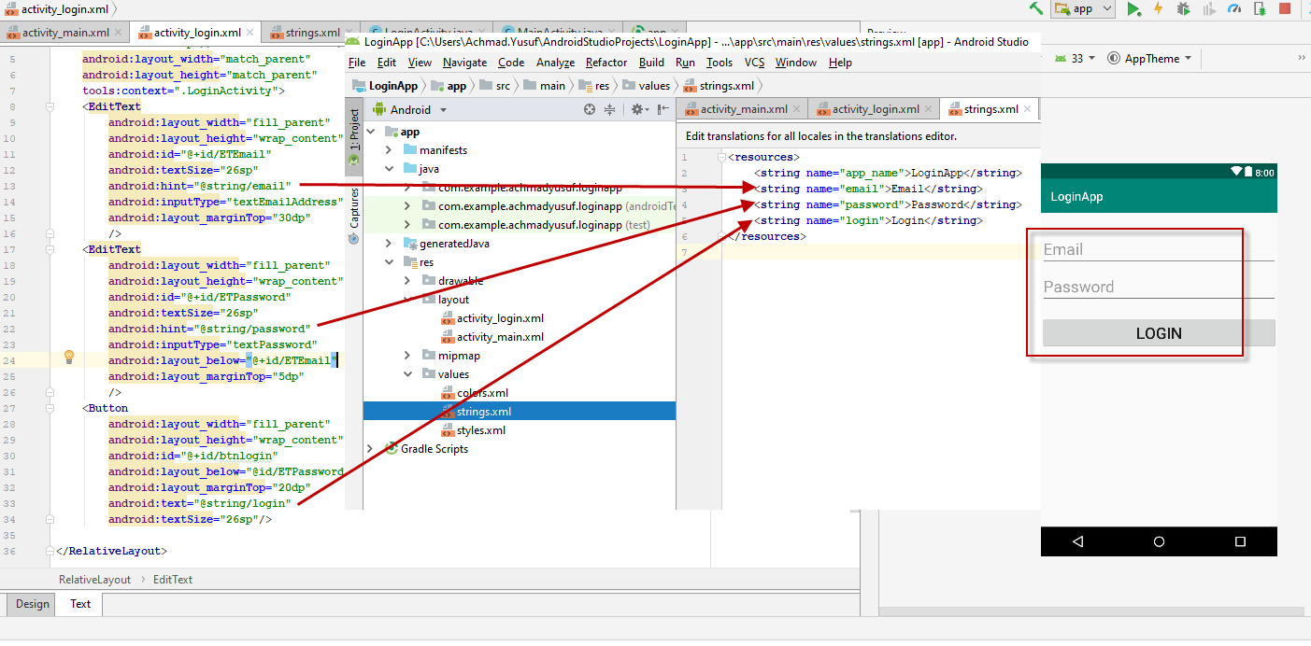

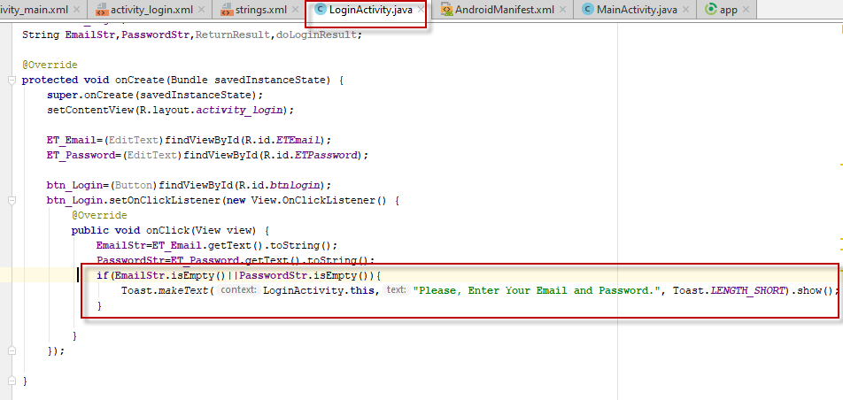

run login activity by pressing green play button, before that goto androidmanifest.xml change .Mainactivity to :login_activity

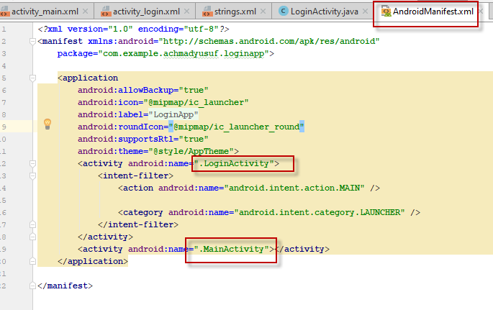

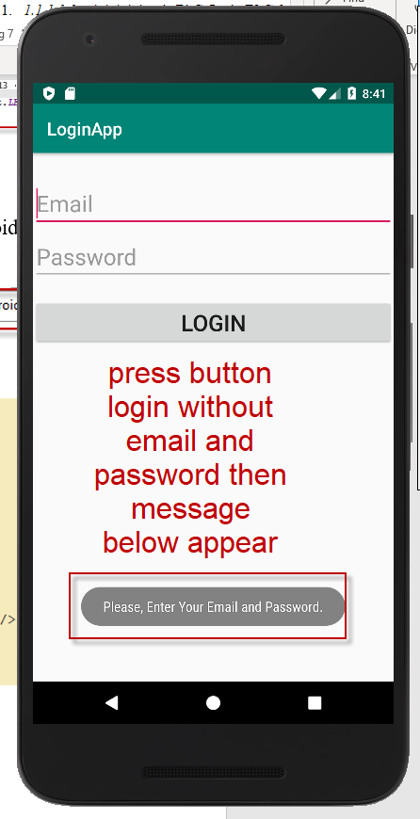

then we will connect our project to ws, we need 1. library ksoap2.jar

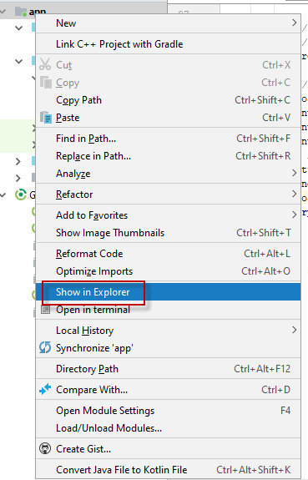

copy file(ksoap2.jar) from github into our project in below path

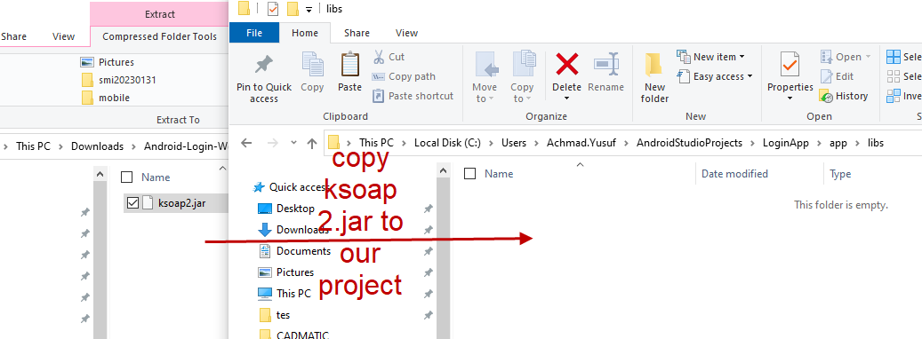

2.import that using android studia, goto app and right click

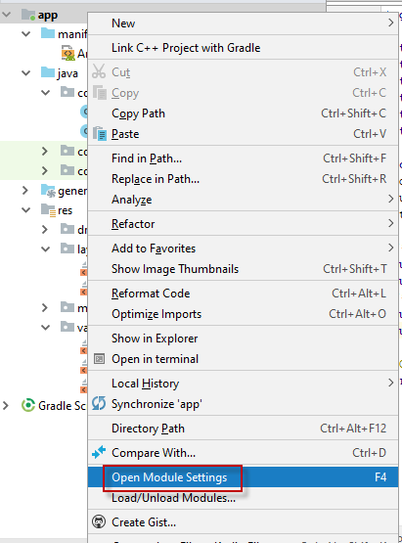

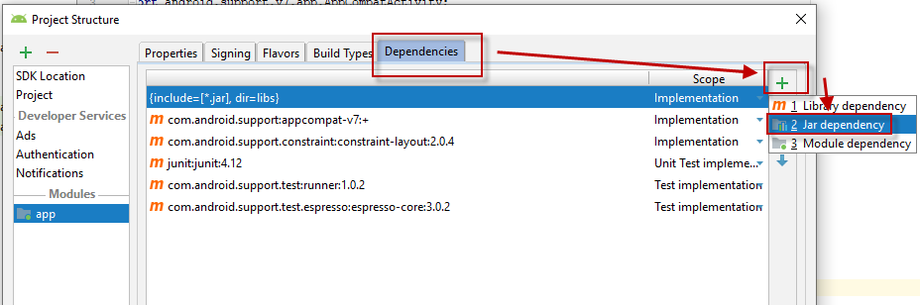

choose dependencies ,+, jar dependency

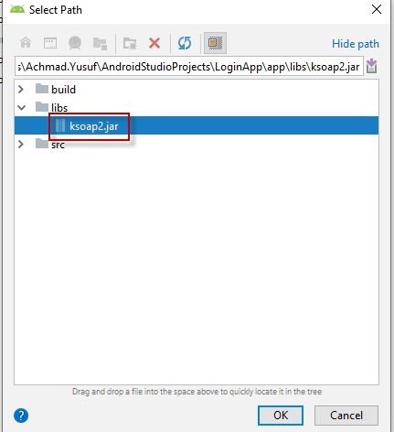

choose the library that we have copied

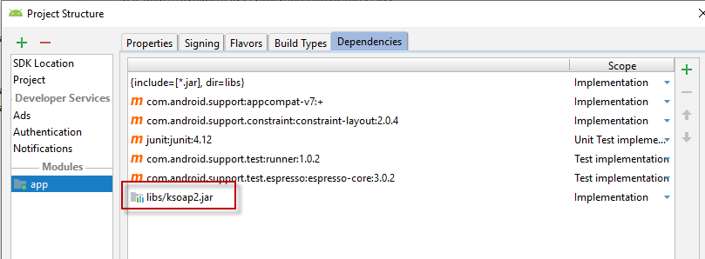

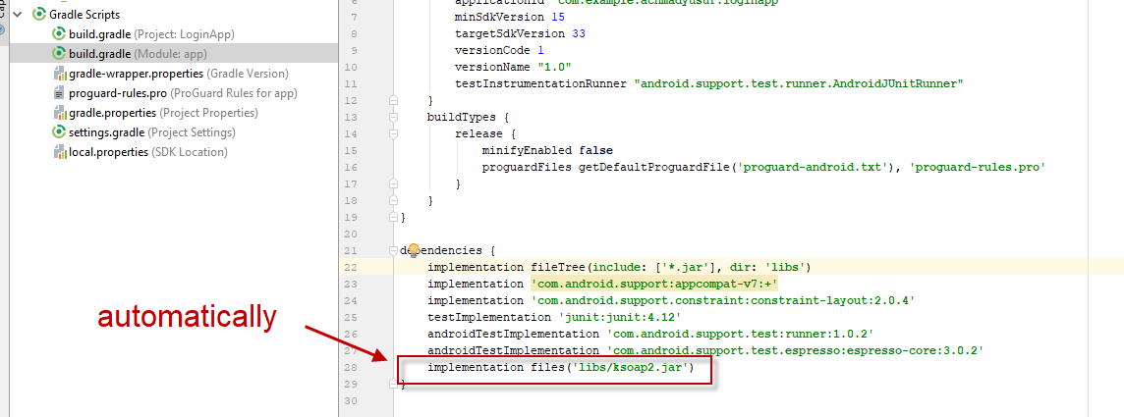

connect to web service

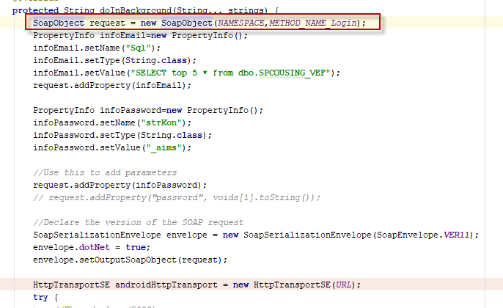

how to debug

create breakpoint(use f8 or left click on left bar) see red bulet below

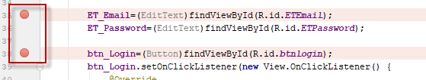

then click icon below green play button

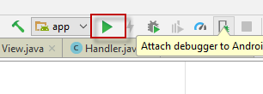

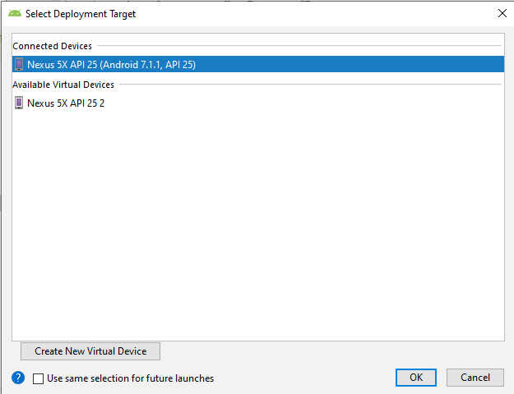

then click attach debugger

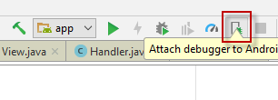

then coose login actifity form

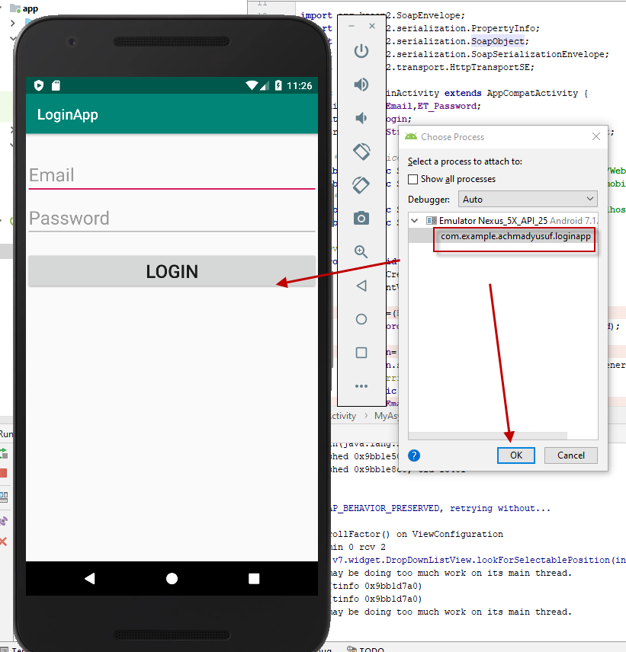

then input email aand password

then press login, goto debug tab

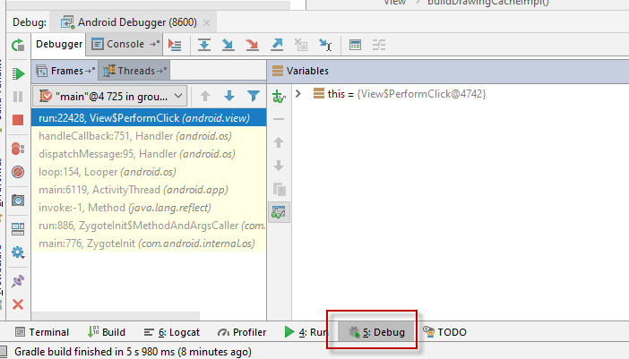

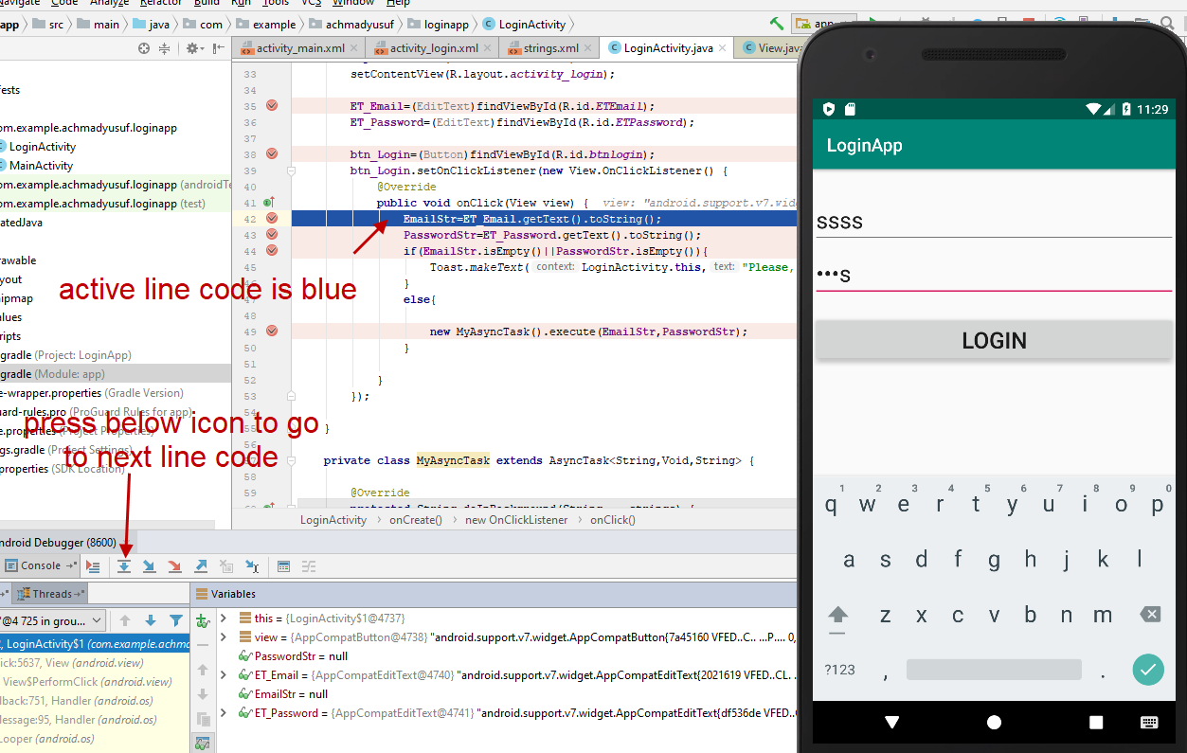

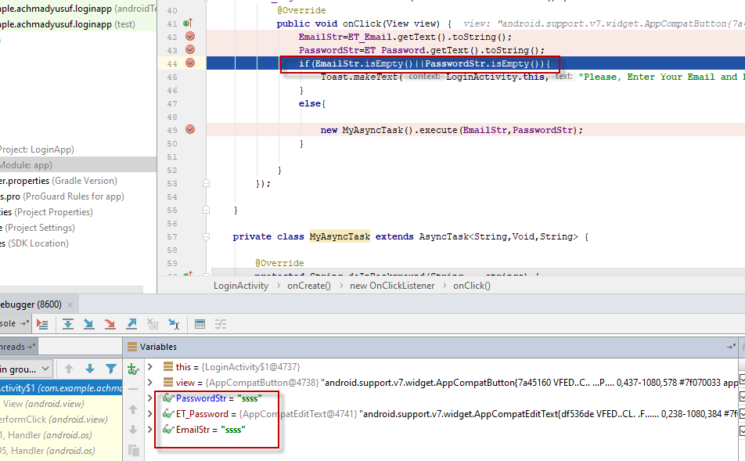

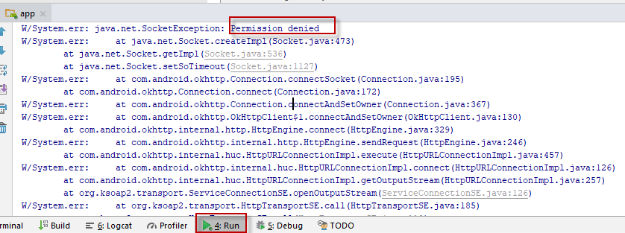

<uses-permission android:name="android.permission.INTERNET"/>

add above line into androidmanifest.xml

run again and test

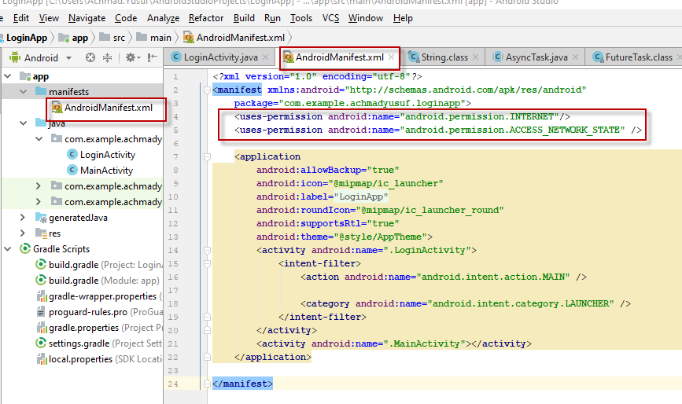

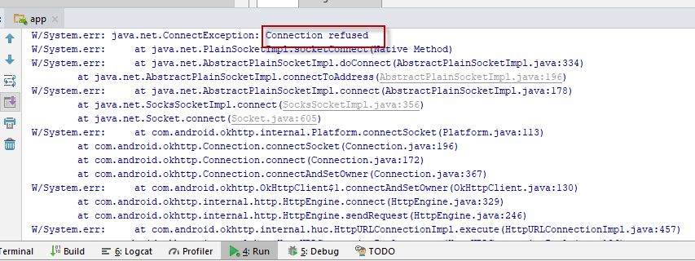

problem with server iis, I change local host to ip address, because android emulator can not find local host

<http://localhost/wsmobile/WebService.asmx?op=GetXml>

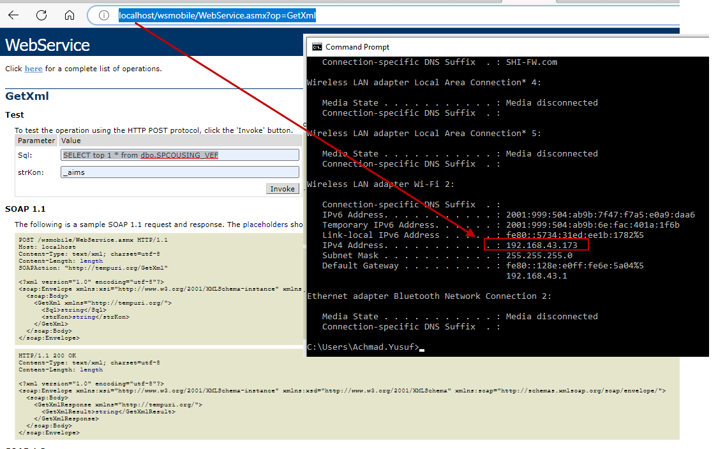

see below picture how we used command in Ksoap.jar

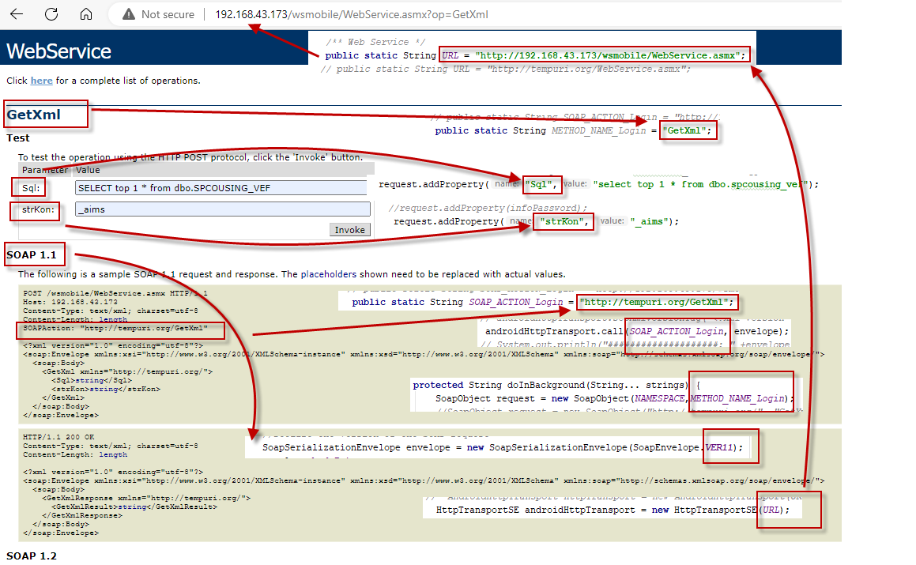

if we use web service from dotnet use below command



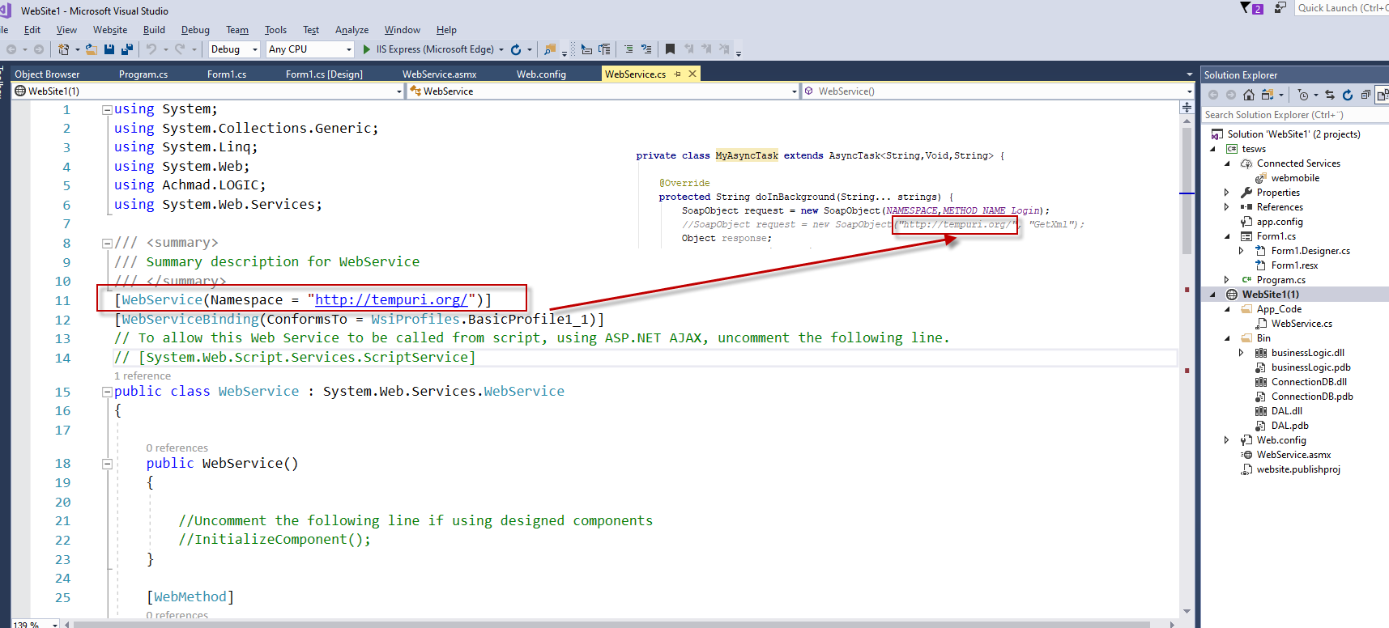

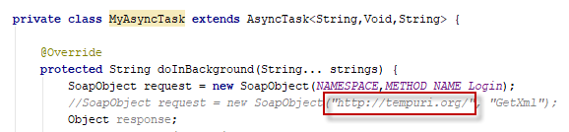

namespace should same with webservice

[[Solved] Android: Problem Consuming Web Service with KSOAP - CodeProject](https://www.codeproject.com/Questions/600990/Android-3aplusProblemplusConsumingplusWebplusServi)

android httptransport

[Programming Articles.: Consume .net webservice in android using ksoap2 (articlesforprogramming.blogspot.com)](http://articlesforprogramming.blogspot.com/2013/06/consume-net-webservice-in-android-using.html)

[java - How to pass parameter to a webservice using ksoap2? - Stack Overflow](https://stackoverflow.com/questions/2108527/how-to-pass-parameter-to-a-webservice-using-ksoap2)

14,2,2023

There is problem with xml

then use XMLparsher

17,2,2023

creating menu in Android base on user level

goto app,res,drawable and right click new vector asset

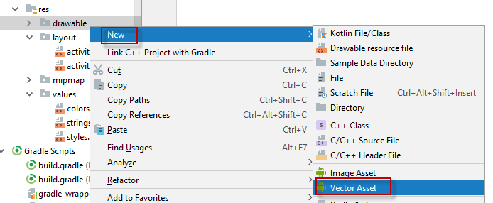

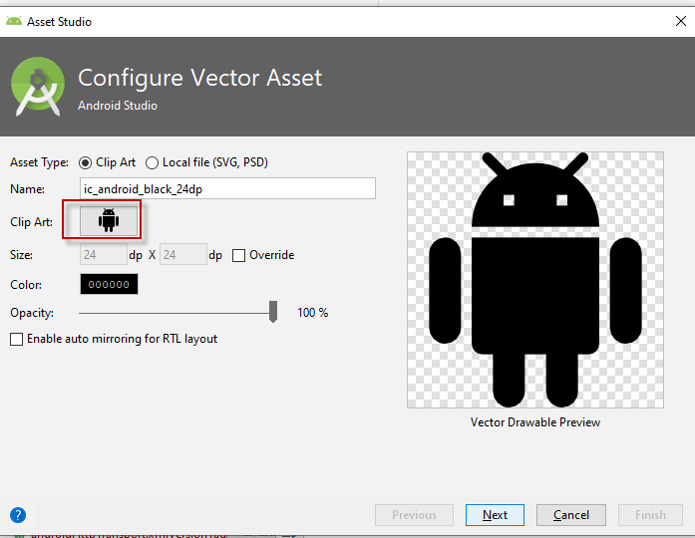

cick clip art button then select desire icon

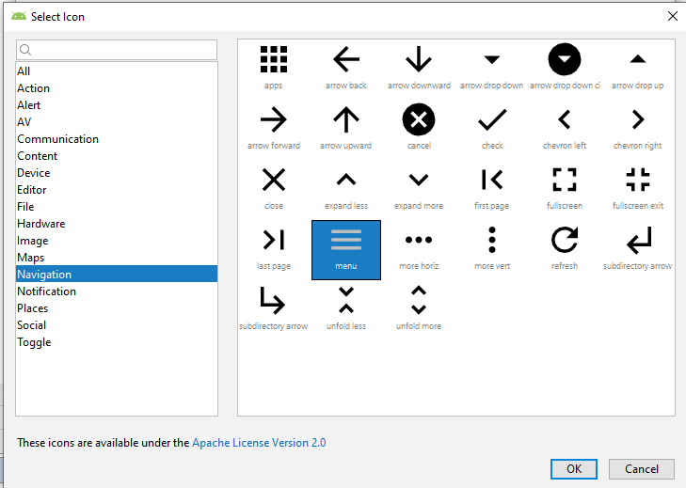

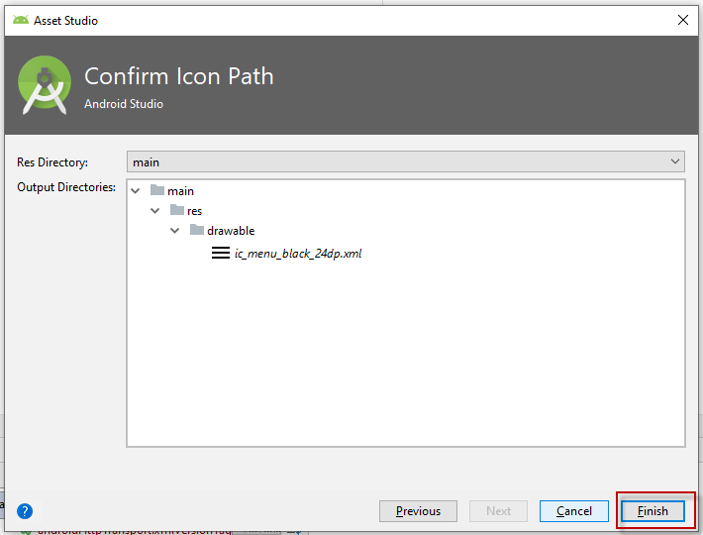

then finnish

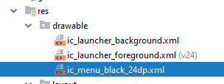

then goto res folder,right click, new, android resource directory

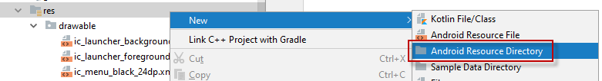

then choose menu

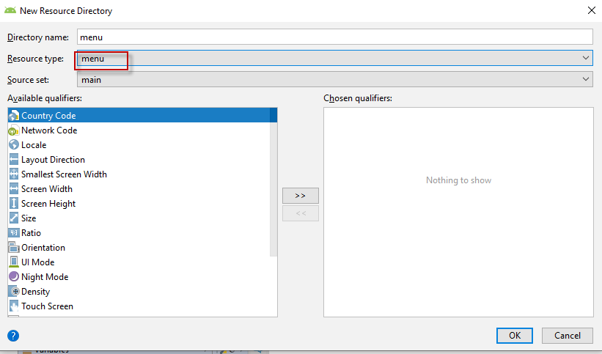

then just ok and menu folder was created

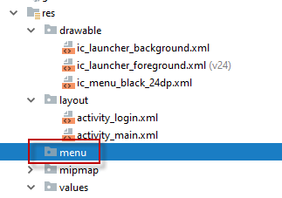

then right click on menu folder, new ,menu resource file

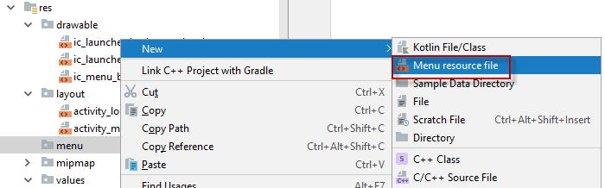

then fill in file filename

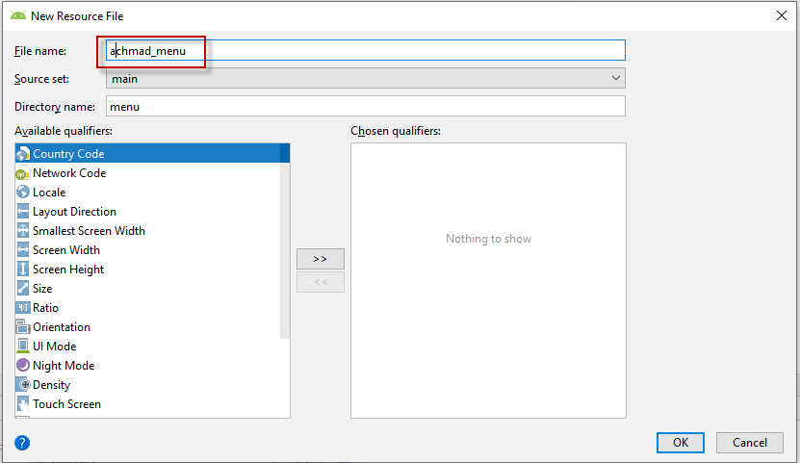

pres ok

then modify achmad_menu

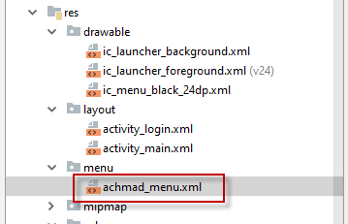

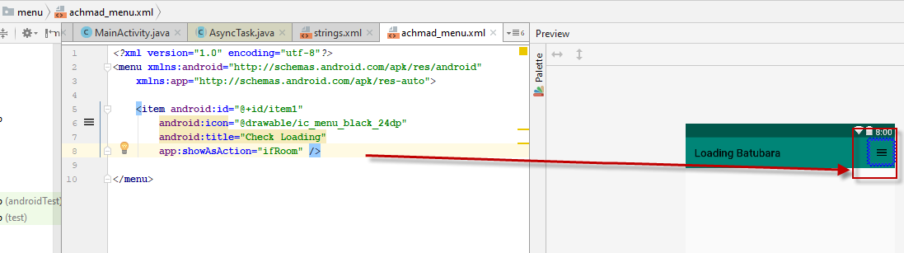

if room for right adjust, then add another item menu

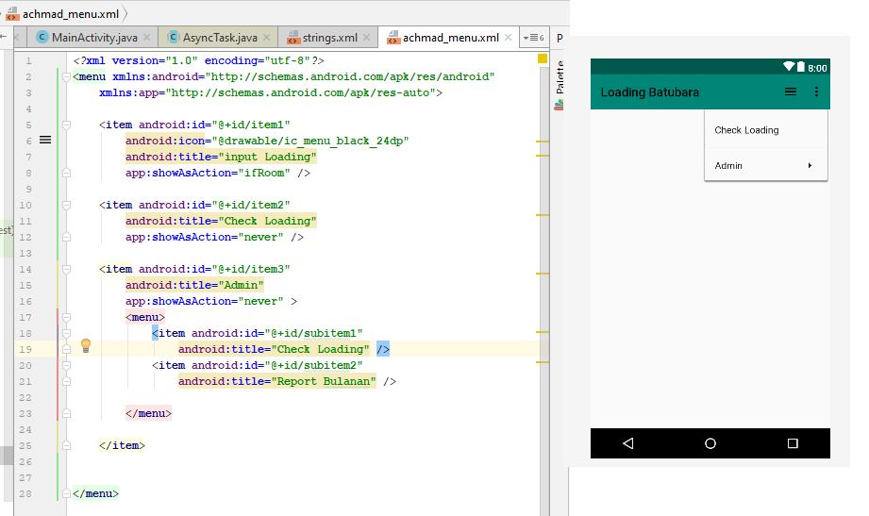

then goto mainactivity.java

18,2,2023

create spinner/ dropdownlist with key and value

create new class

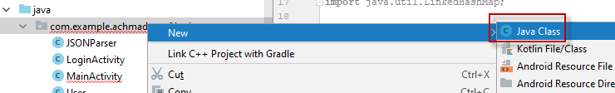

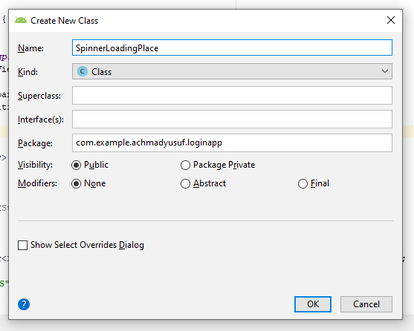

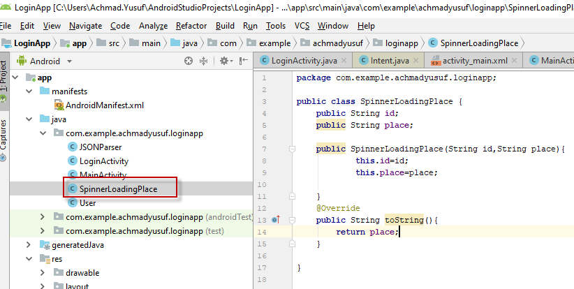

id is place code, place is loading location

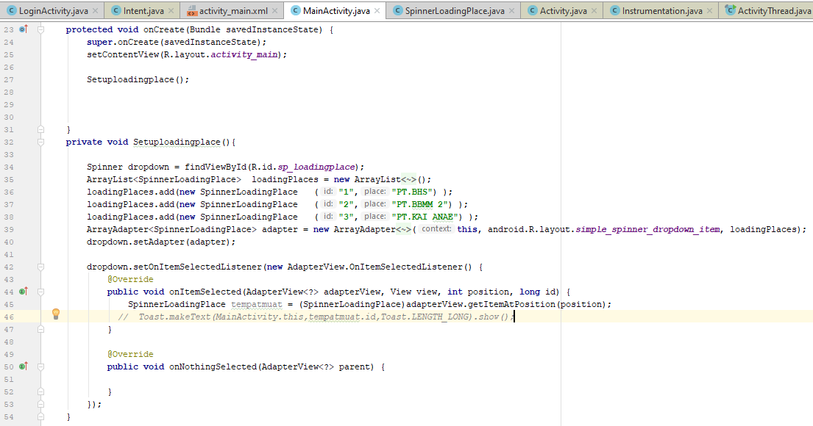

[(12) Set key and value in spinner - YouTube](https://www.youtube.com/watch?v=rZpyHCyzAHo)

19,2,2023 Creating datepicker

[(28) Pop Up Date Picker Android Studio Tutorial - YouTube](https://www.youtube.com/watch?v=qCoidM98zNk)

insert picture

28,2,2023 create

1.create empetyactivity for gridtempalte

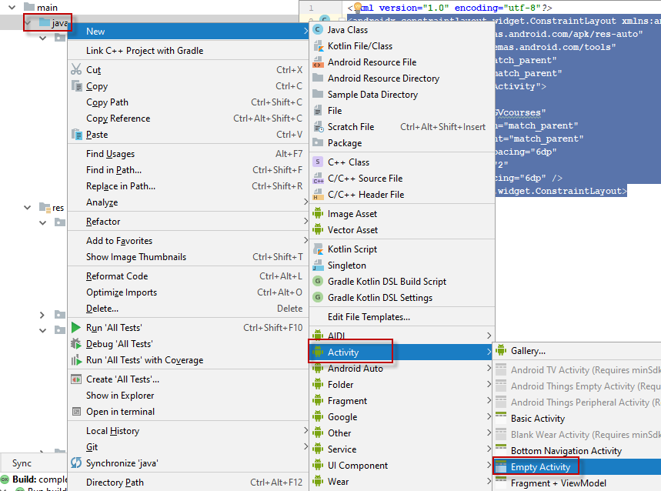

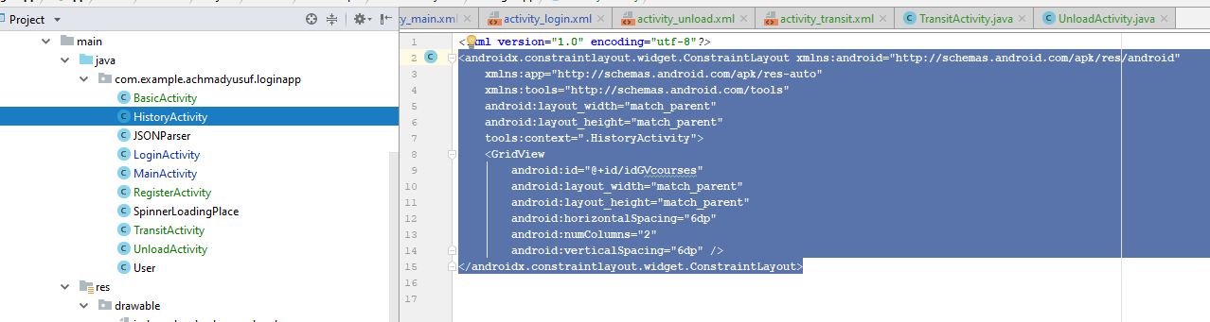

2.create item grid

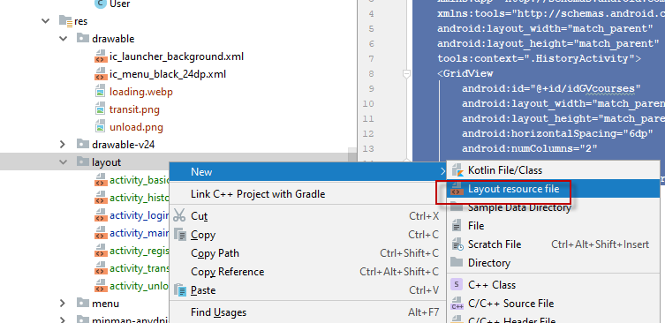

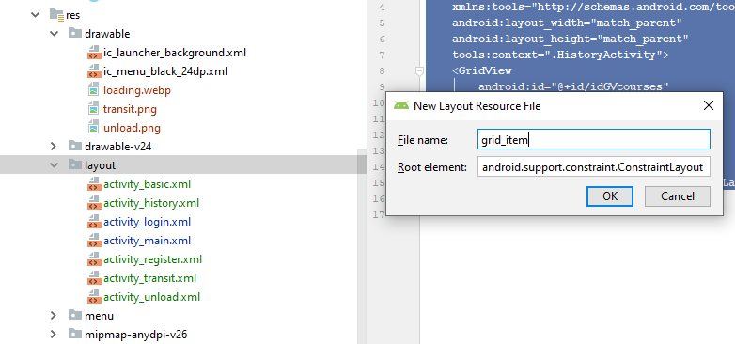

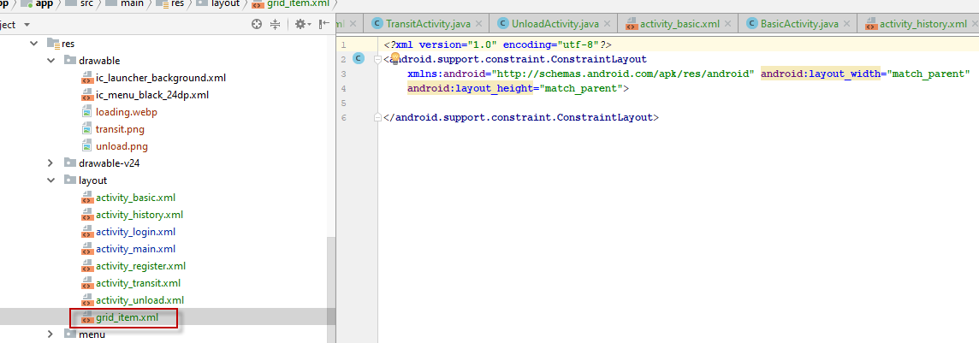

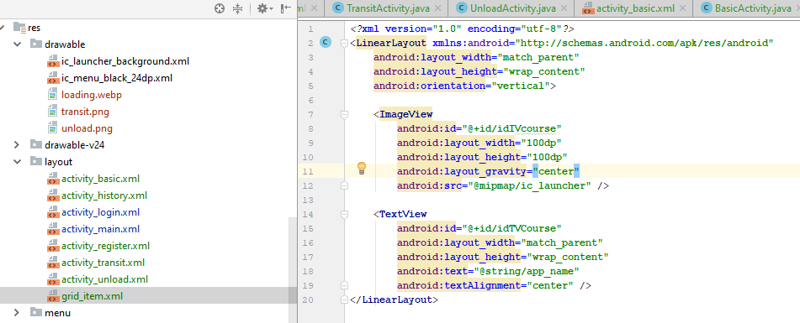

add dependency

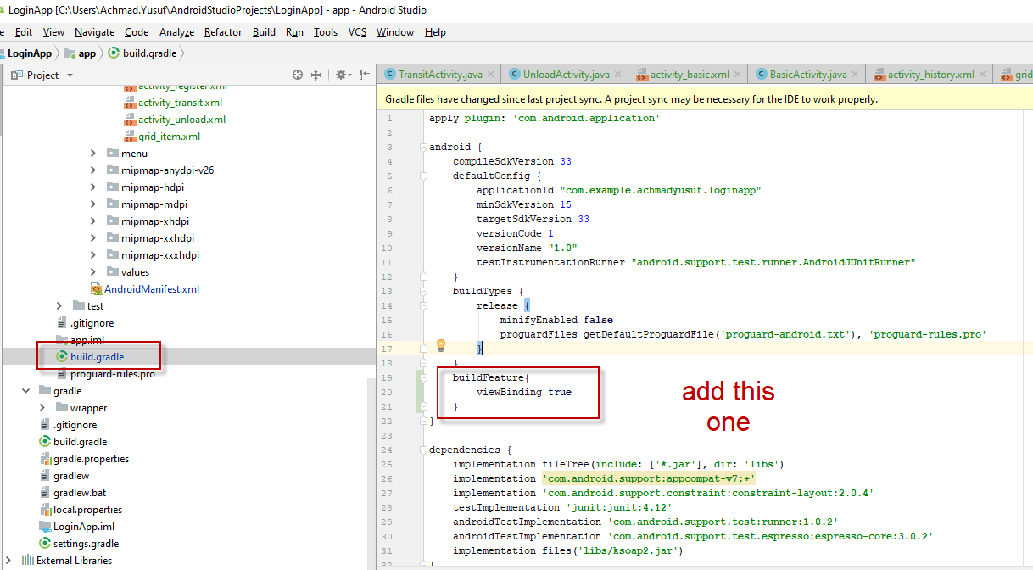

add javaadapterclass

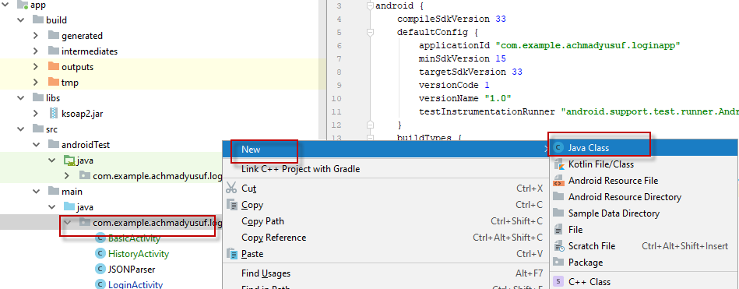

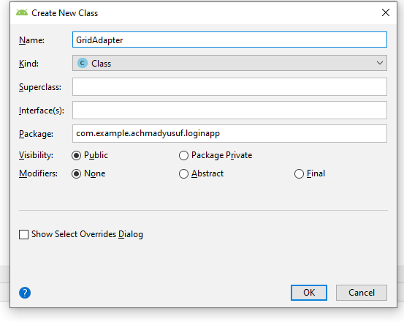

and implement this class

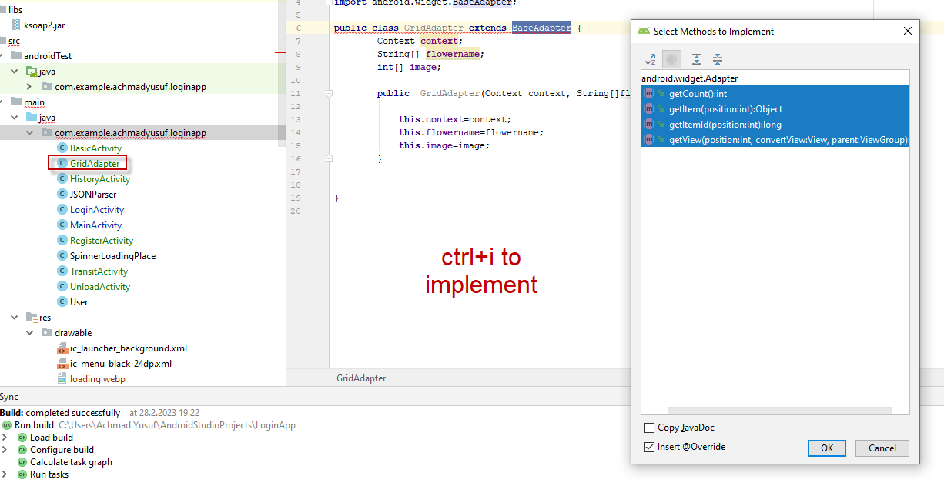

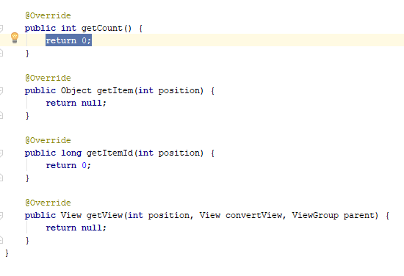

[(52) Fill Data From SQL To GridView In Android Studio Using Java | ProgrammingGeek - YouTube](https://www.youtube.com/watch?app=desktop&v=pounupI4tMA)

[Stock artwork titled Dump Car Icons Set Vector on White Background - Download Image Now - iStock (istockphoto.com)](https://www.istockphoto.com/fi/vektori/dumppausauton-kuvakkeet-asetettu-vektori-valkoisella-taustalla-gm1155715670-314741825)

[(62) #Android #SDK #SQL Server WebService part3 - YouTube](https://www.youtube.com/watch?v=aFrPe654spk)

[Learning in English or Swedish | Jyväskylä.fi (jyvaskyla.fi)](https://www.jyvaskyla.fi/en/daycare-and-education/education-foreigners-basic-education/learning-english-or-swedish)

[(78) Android SDK SQL Server WebService part1 - YouTube](https://www.youtube.com/watch?v=otI9K5wEMoI)

[How to Create a Simple Web Service and Use it in ASP.Net (c-sharpcorner.com)](https://www.c-sharpcorner.com/UploadFile/29d7e0/steps-to-create-a-simple-web-service-and-use-it-in-Asp-Net/)

then i create Backend using C#

create layering Data access

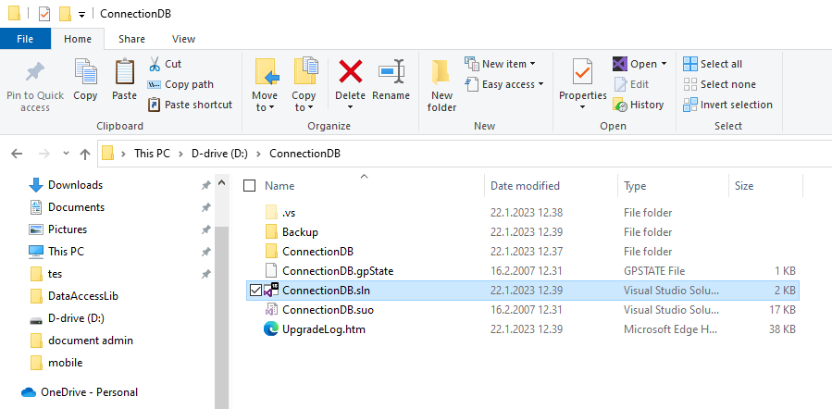

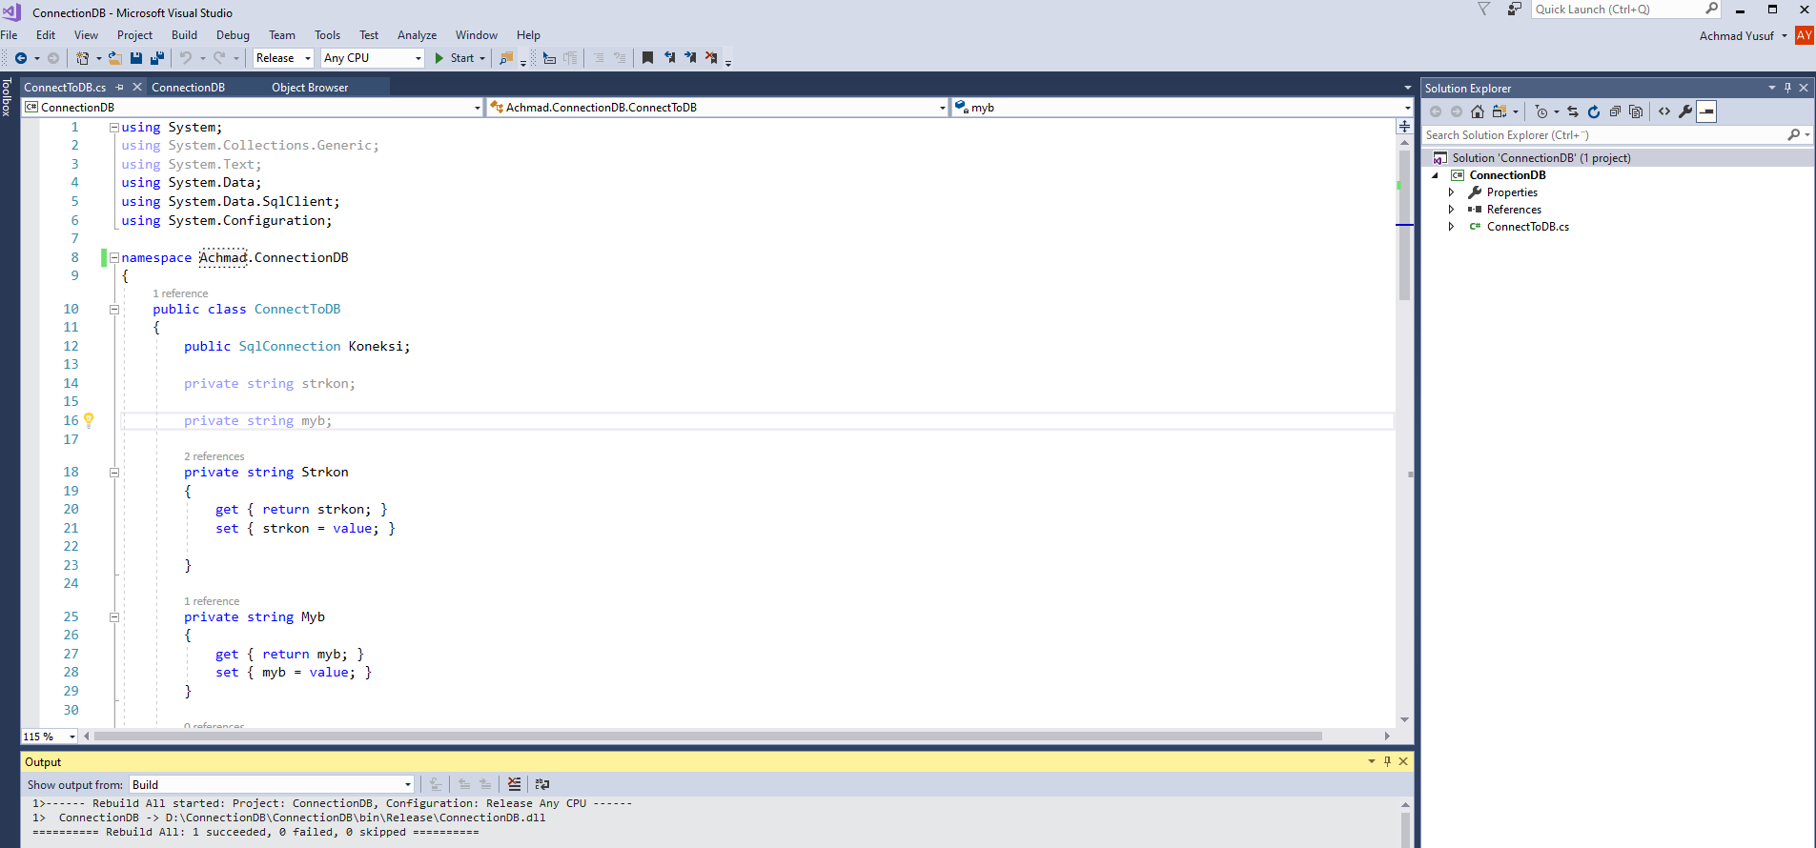

using System;

using System.Collections.Generic;

using System.Text;

using System.Data;

using System.Data.SqlClient;

using System.Configuration;

namespace Achmad.ConnectionDB

{

public class ConnectToDB

{

public SqlConnection Koneksi;

private string strkon;

private string myb;

private string Strkon

{

get { return strkon; }

set { strkon = value; }

}

private string Myb

{

get { return myb; }

set { myb = value; }

}

public ConnectToDB(string mydb)

{

myb = mydb;

Strkon = BacaApp();

Koneksi = new SqlConnection(Strkon);

}

public bool OpenDB()

{

bool _hasil= false;

try

{

CloseDB();

Koneksi.Open();

_hasil = true;

}

catch (Exception ex)

{

throw ex;

}

return _hasil;

}

public void CloseDB()

{

if (Koneksi.State == ConnectionState.Open)

{

Koneksi.Close();

}

}

private string BacaApp()

{

ExeConfigurationFileMap fileMap = new ExeConfigurationFileMap();

// You may want to map to your own exe.comfig file here.

fileMap.ExeConfigFilename = @"D:\Config\App.config";

System.Configuration.Configuration config = ConfigurationManager.OpenMappedExeConfiguration(fileMap,ConfigurationUserLevel.None);

ConnectionStringSettings connstr = config.ConnectionStrings.ConnectionStrings[Myb];

String strConn = connstr.ConnectionString;

return strConn;

}

}

}

now we will test this Connection

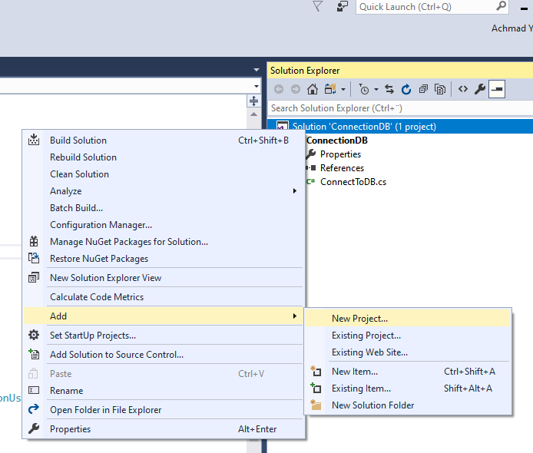

create new project windows app

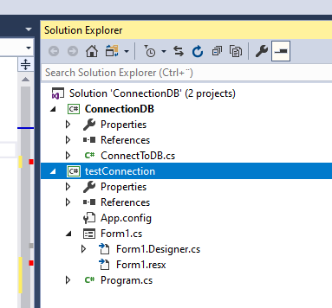

test connection project have been made then we include connectiondb.dll

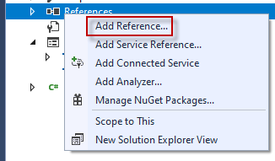

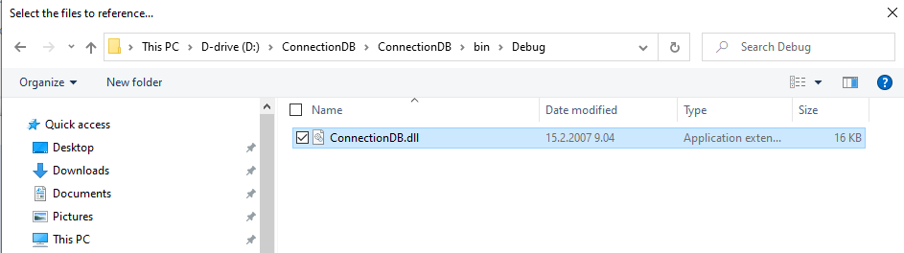

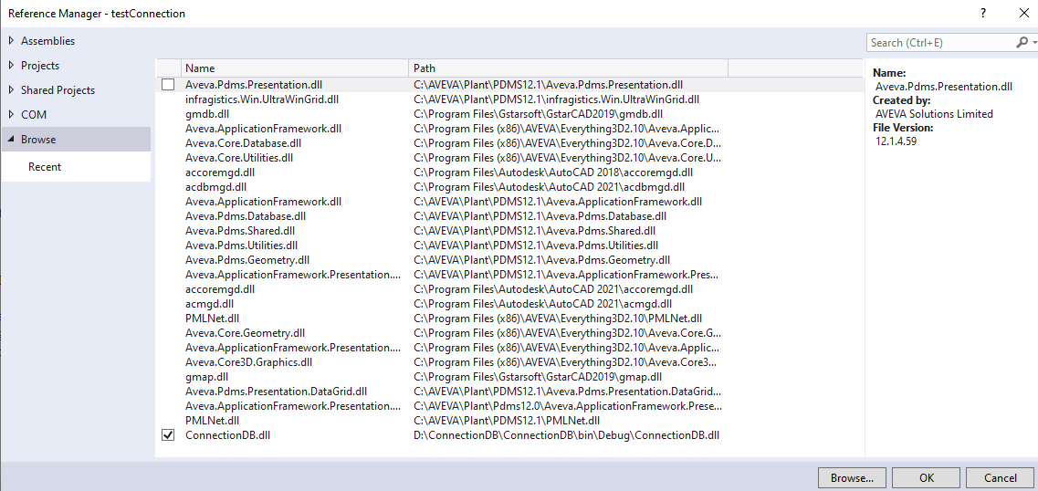

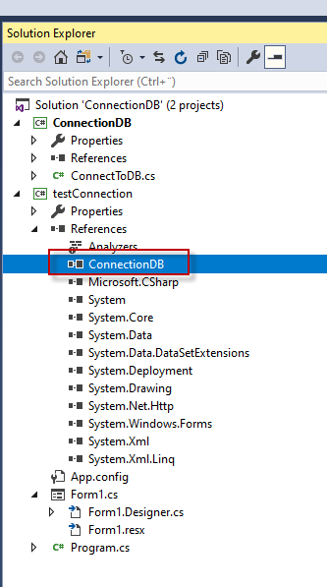

connectiondb already include now

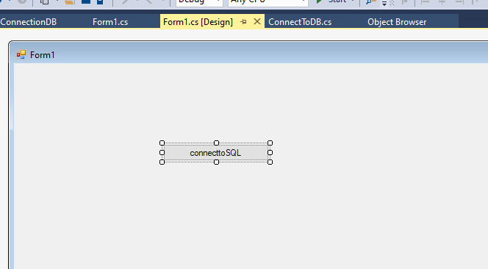

then set up testconnection as startup

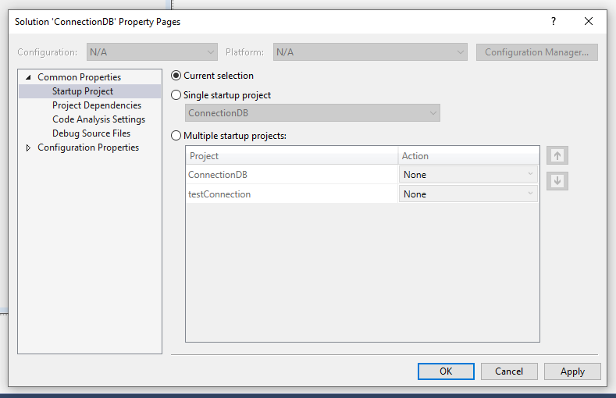

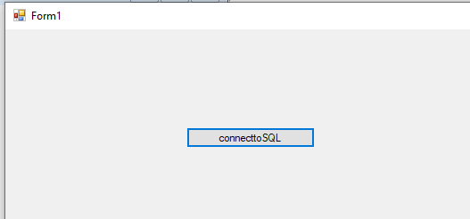

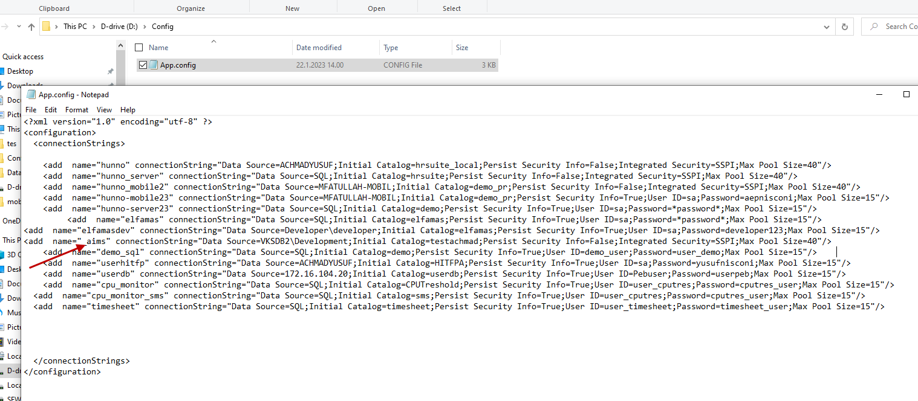

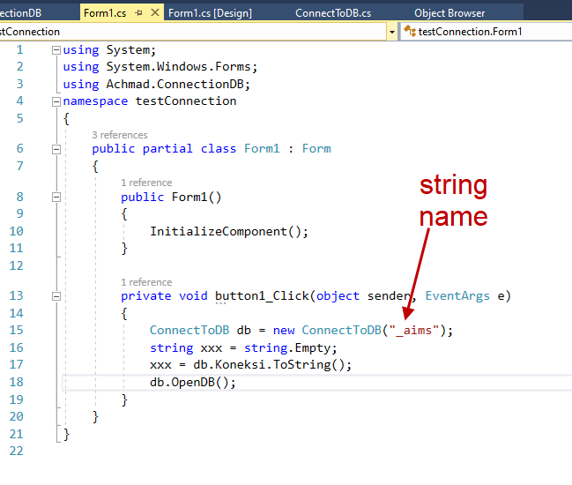

jadi jika ganti database Cuma ganti tag name di dalam connection string(<add name=”_aims”).

now kita bikin Crud (Create update delete) DAL data access layer

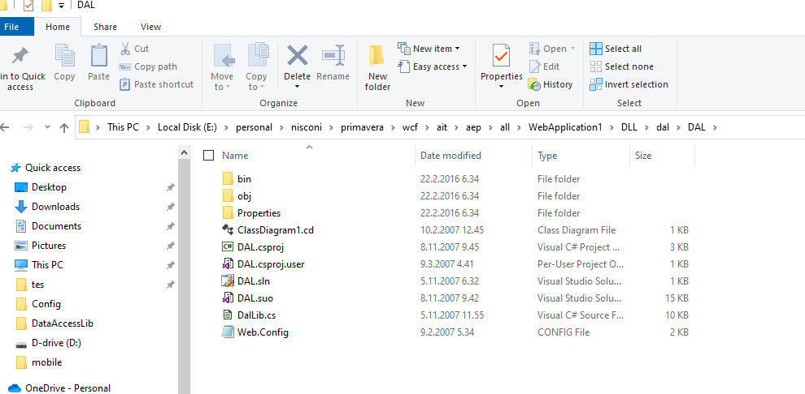

kita copy ke folder lain buka dan edit

remove connectiondb yg lama

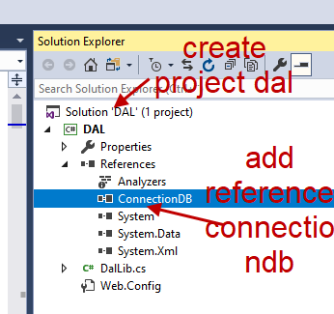

bikin business logic

bikin webservice

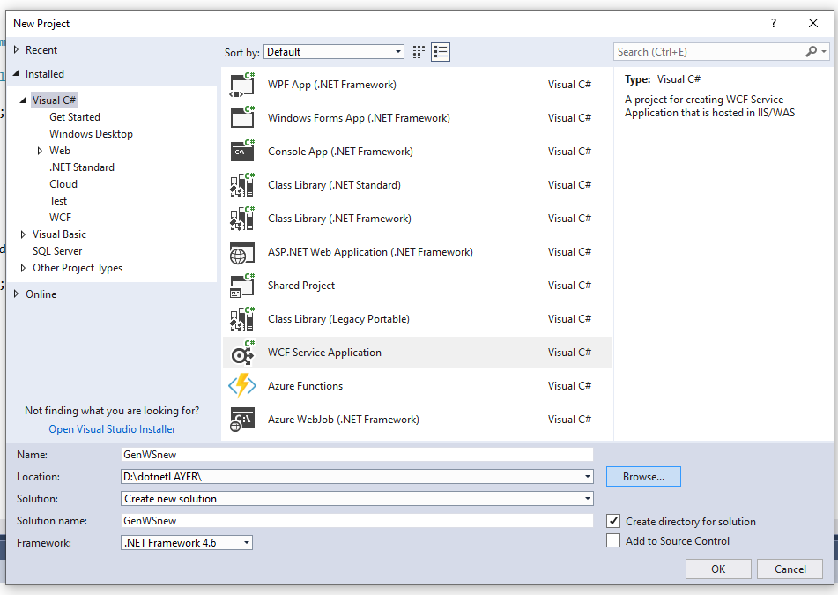

tes ws

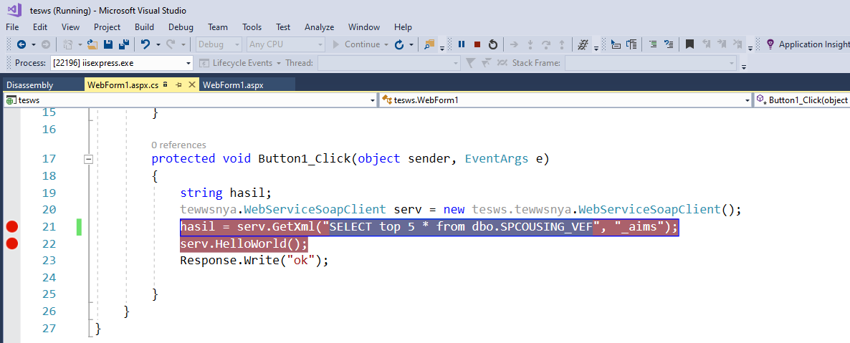

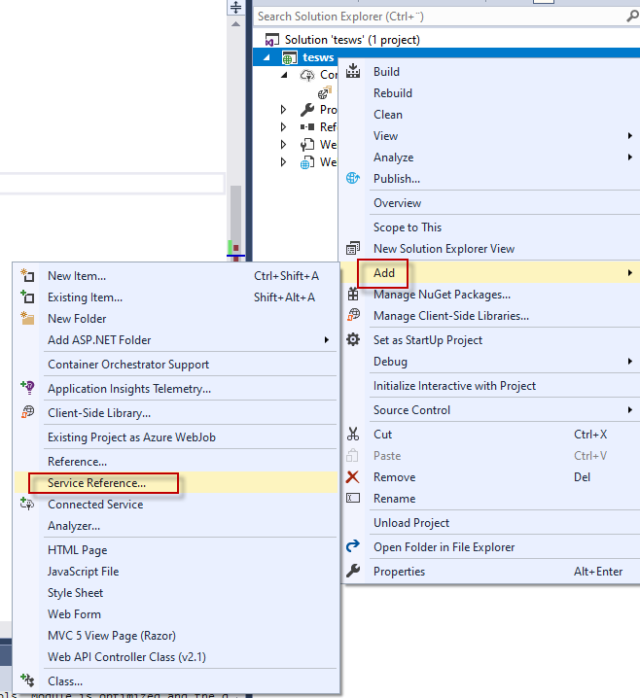

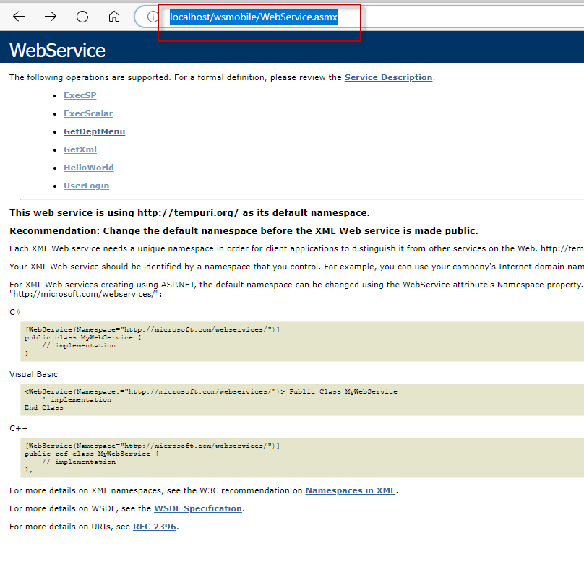

[WebService Web Service](http://localhost/wsmobile/WebService.asmx) copy this link (1) klik button go(2) then type namespace(3) see below picture

link for Crud without WS

[(7) Get Data From SQL to TextView in Android Studio Using Java Step By Step - YouTube](https://www.youtube.com/watch?v=-vca9x_d28U)

[(42) Whatsapp integration in android | how to open whatsapp in android programmatically | Android Studio - YouTube](https://www.youtube.com/watch?v=V2uDq4Gm53w)

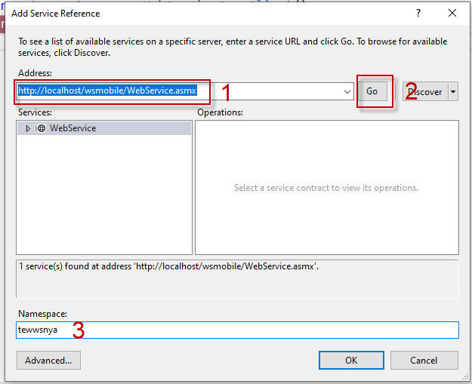

now we test use “tewwsnya”

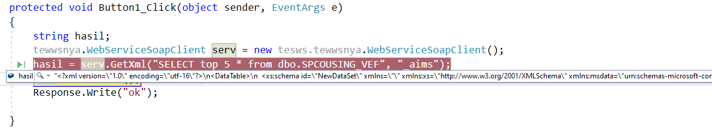

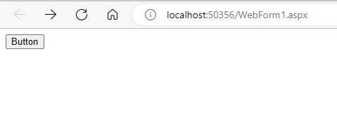

setelah button dijalankan muncullah pesan dibawah ini

got 5 record

"<?xml version=\"1.0\" encoding=\"utf-16\"?>\n<DataTable>\n <xs:schema id=\"NewDataSet\" xmlns=\"\" xmlns:xs=\"http://www.w3.org/2001/XMLSchema\" xmlns:msdata=\"urn:schemas-microsoft-com:xml-msdata\">\n <xs:element name=\"NewDataSet\" msdata:IsDataSet=\"true\" msdata:MainDataTable=\"Table\" msdata:UseCurrentLocale=\"true\">\n <xs:complexType>\n <xs:choice minOccurs=\"0\" maxOccurs=\"unbounded\">\n <xs:element name=\"Table\">\n <xs:complexType>\n <xs:sequence>\n <xs:element name=\"NAMEOBJ\" type=\"xs:string\" minOccurs=\"0\" />\n <xs:element name=\"TYPE\" type=\"xs:string\" minOccurs=\"0\" />\n <xs:element name=\"DTXR\" type=\"xs:string\" minOccurs=\"0\" />\n <xs:element name=\"CATRE\" type=\"xs:string\" minOccurs=\"0\" />\n <xs:element name=\"SPEC\" type=\"xs:string\" minOccurs=\"0\" />\n </xs:sequence>\n </xs:complexType>\n </xs:element>\n </xs:choice>\n </xs:complexType>\n </xs:element>\n </xs:schema>\n <diffgr:diffgram xmlns:msdata=\"urn:schemas-microsoft-com:xml-msdata\" xmlns:diffgr=\"urn:schemas-microsoft-com:xml-diffgram-v1\">\n <NewDataSet>\n <Table diffgr:id=\"Table1\" msdata:rowOrder=\"0\">\n <NAMEOBJ>FLANGE 1 of BRANCH 1 of PIPE /flangeset-PIPE</NAMEOBJ>\n <TYPE>FLAN</TYPE>\n <DTXR>FLANGE WN ANSI B16.5 #150.RF</DTXR>\n <CATRE>AAFWBB0JJ</CATRE>\n <SPEC>A150/WNRF:50</SPEC>\n </Table>\n <Table diffgr:id=\"Table2\" msdata:rowOrder=\"1\">\n <NAMEOBJ>GASKET 1 of BRANCH 1 of PIPE /flangeset-PIPE</NAMEOBJ>\n <TYPE>GASK</TYPE>\n <DTXR>GASKET ANSI B16.21 #150.RF</DTXR>\n <CATRE>ABGCBBGJJ</CATRE>\n <SPEC>A150/GRF:50</SPEC>\n </Table>\n <Table diffgr:id=\"Table3\" msdata:rowOrder=\"2\">\n <NAMEOBJ>FLANGE 2 of BRANCH 1 of PIPE /flangeset-PIPE</NAMEOBJ>\n <TYPE>FLAN</TYPE>\n <DTXR>FLANGE WN ANSI B16.5 #150.RF</DTXR>\n <CATRE>AAFWBB0JJ</CATRE>\n <SPEC>A150/WNRF:50</SPEC>\n </Table>\n <Table diffgr:id=\"Table4\" msdata:rowOrder=\"3\">\n <NAMEOBJ>TEE 1 of BRANCH 1 of PIPE /flanged-tee-PIPE</NAMEOBJ>\n <TYPE>TEE</TYPE>\n <DTXR>TEE ANSI B16.9 BW STD</DTXR>\n <CATRE>AATA200RR</CATRE>\n <SPEC>A150/ST:150_150</SPEC>\n </Table>\n <Table diffgr:id=\"Table5\" msdata:rowOrder=\"4\">\n <NAMEOBJ>FLANGE 1 of BRANCH 2 of PIPE /flanged-tee-PIPE</NAMEOBJ>\n <TYPE>FLAN</TYPE>\n <DTXR>FLANGE WN ANSI B16.5 #150.RF</DTXR>\n <CATRE>AAFWBB0RR</CATRE>\n <SPEC>A150/WNRF:150</SPEC>\n </Table>\n </NewDataSet>\n </diffgr:diffgram>\n</DataTable>"